This term the year 2 topic will be……..
In Maths we are learning to…
… add and subtract 2 digit numbers
… multiply and divide
… learn facts from the 2,5 and 10 times table
... Estimate and measure length using m and cm
…recognise and name 3D shapes and describe their properties.
…. Tell the time to the nearest 5 minutes

Kenya
In English we are learning to…
… write poems about winter
… identify nouns, verbs and adjectives
… listen to and respond to stories based in Africa
… find out facts about African animals
… make animal fact sheets
… write riddles about African animals

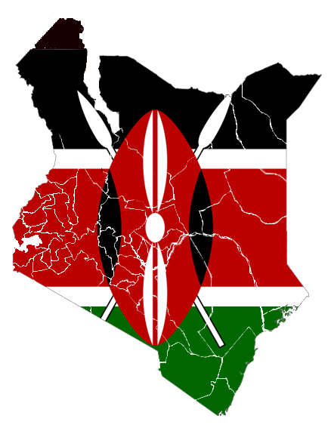
In Art we are …
……painting African animals
…..making collages
……exploring pattern and animal prints
……making masks
…...observational drawing

In music we are … learning about African drumming and songs (Drumming visit to school (Tuesday 15th January)

In Geography we are …
… naming and locating continents and oceans
…….using maps, atlases and globes
……identifying and describing what places are like
…… To recognise and name physical landscape features.
……. To consider similarities and differences between their lives and those of a child in another country.

In PSHE we are thinking about …
Dreams and Goals
Healthy Me
In PE we are …
……working with a dance teacher on an African themed dance

In computing we are …
….. learning about internet safety
…. Researching on the internet
…. Making power points / word documents
We will finish the term with a Science topic on plants. .


