PUDDLETOWN VC CE FIRST SCHOOL NEWSLETTER

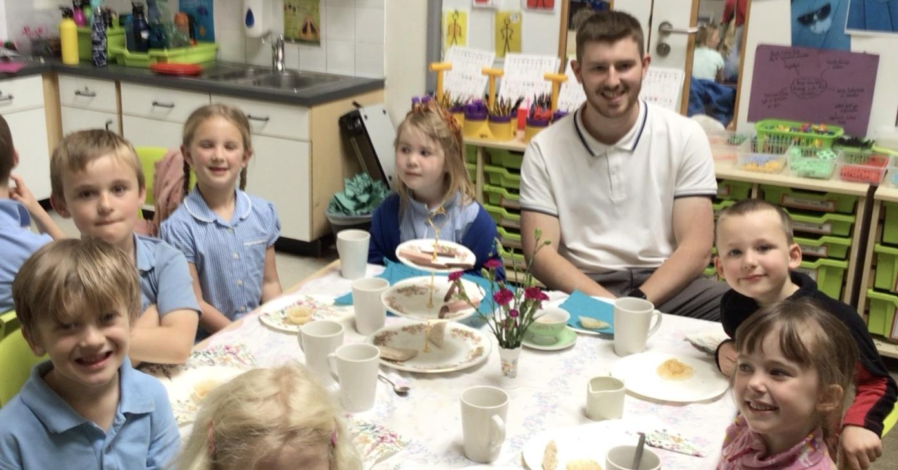 | 
 | May 2024
May 2024 News | Reminders
The Summer term is such a lovely term for our children. Walking around at lunchtime seeing children playing together across the year groups amongst a sea of daisies, surrounded by trees and hearing the skylarks sing we feel truly blessed to be able to educate your children here. There have been visits to hear the Bournemouth Symphony orchestra for years 3 and 4, a music roadshow and a guitar performance from our own very talented children. We want to expose our children to as many musical experiences as possible because at Puddletown we strive to develop the whole child. Looking forward to developing this further, I would like to create the concept of ‘the Puddletown Pledge’. This would be around 50 experiences that we believe every child should have experienced by the time they leave us. Opportunities like hearing an orchestra, planting a tree, seeing a live theatre performance, growing some food etc etc. I would love to gather your ideas to add to our list so please email or pop an idea in our suggestion box that we will put in the foyer. We will also consult the staff, governors and pupils so that we can all contribute to this.  There will also be a parent survey winging its way to you soon so that we can gather your views to help us understand what we do well and what we can do even better in the coming year.  Before half term we said Goodbye to our student teacher Mr Clarke who has completed his training and secured his first teaching position in another school. Year 1 gave him a wonderful send off with a proper formal tea party. It has been wonderful to have Mr Clarke with us, we will miss him and wish him all the best in his new position.  We are all looking forward to the next half term with all our transition activities, sports day, farm visits and of course the year 4 leavers assembly.  Don’t forget the FOPS end of year social on Friday 12th July.  Mrs Anna Seal Head of school | There are many activities happening over the next few weeks and the best place to see the dates is on our website calendar.  As/when the weather warms up please put sun protection on at home and send your child in with a hat.  Thank you all for endeavouring to get your children to school on time and our attendance figures are improving. However recently we have had a lot of requests for term time holidays which while we understand the reasons why parents may choose to do this, we cannot authorise them and strongly request that you take holidays within the 13 weeks a year already given.

