Reception Puddletown First School EYFS Long Term Planning 2024-2025
Area of Learning | Autumn 1 | Autumn 2 |  | Spring 1 |  | Spring 2 | Summer 1 | Summer 2
Topic and  Intention | Me and My Community  This project teaches children about the different communities that they are part of and explores themes including family, friendship, school and people who help in the local community.  Exploring Autumn    This mini project teaches children about the natural changes that happen during autumn, including how the weather changes, why trees lose their leaves and how wild animals prepare for the cold weather coming in winter. | Once Upon a Time    This language-rich project supports children to develop a love of stories and reading. It encourages children to learn, retell and act out familiar and traditional tales, including Goldilocks, The Three Little Pigs and Cinderella.  Sparkle and Shine    This mini project teaches children about the celebrations and traditions that take place during the winter holiday season, both in the UK and around the world. |  | Dangerous Dinosaurs    This exciting interest-led project teaches children about the different creatures that roamed Earth millions of years ago and how they are related to animals that live on Earth today.  Puddles and Rainbows    This mini project teaches children about the weather that happens during spring and allows them to explore natural phenomena, including rainbows. |  | Ready Steady Grow    This project teaches children about food and farming and explores themes, including where food comes from, what plants and animals need to grow and survive and the importance of a healthy, balanced diet.  Signs of Spring    This mini project teaches children about the changes that happen during spring, including how the weather changes and festivals that are celebrated at this time of year. | Animal Safari    This interest-led project teaches children about the animals that live all around the world and the importance of caring for our local and global environments.  Creep, Crawl and Wriggle  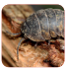  This mini project teaches children about the tiny creatures that live in their gardens and local environment. | On the Beach    This project teaches children about the plants and animals that live at the seaside. It also explores holidays in the past and the importance of keeping safe in the sunshine.  Move It    This mini project teaches children about the importance of daily exercise to keep healthy and explores the different types of games and activities that they can play outside in summer.
Communication and Language   | Understand how to listen carefully and why listening is important.  Engage in story times, rhymes, and songs.  Maintain attention in whole class/groups.  Follow 1 step instructions.  Understand ‘why’ questions.  Use sentences 4-6 words.  Use talk to organise play. | Listen in familiar & new situations.  Engage in story times.  Maintain attention in new situations.  Ask questions to find out more and to check they understand what has been said to them.  Follow instructions with 2 parts in a familiar situation.  Start a conversation with peers and familiar adults and continue for many turns.  Develop social phrases |  | Listen attentively in a range of situations.  Maintain attention during appropriate activity.  Engage in non-fiction books.  Consider the listener and take turns.  Use talk to organise/stand for something else in play.  Begin to use past tense.  Begin to recount past events. |  | Understand why listening is important.  Maintain attention in different contexts.  Use talk to help work out problems and organise thinking and activities explain how things work and why they might happen.  Ask questions to find out more and check understanding.  Articulate their ideas and thoughts in well-formed sentences.  Listen to and talk about selected non-fiction to develop a deep familiarity with new knowledge and vocabulary  Begin to connect one idea or action to another using a range of connectives.  Describe events in some detail. | Listen and understand instructions while busy with another task.  Maintain activity while listening.  Understand how, why, where questions.  Describe events in some detail.  Express ideas about feelings and experiences.  Articulate their ideas and thoughts in well-formed sentences.  Use language to reason. | Listen and respond with relevant questions, comments, or actions.  Attend to others in play.  Make comments and clarify thinking with questions.  Retell the story once they have developed a deep familiarity with the text; some as exact repetition and some in their own words.  Speak in well-formed sentences with some detail.  Use new vocabulary in different contexts.  Use past, present, and future tenses in conversation with peers and adults. Use conjunctions to extend and articulate their ideas.
Learn new vocabulary Listen carefully to rhymes and songs, paying attention to how they sound. Use new vocabulary in different contexts
Use new vocabulary through the day Learn rhymes, poems, and songs. Listen to and talk about stories to build familiarity and understanding.
Personal, Social and Emotional Development  Self-regulation   | Can talk about feelings.  Welcome distractions when upset.  Increasingly follow rules.  Know likes and dislikes.  Independently organise belongings in the morning.  Manage personal hygiene.  Build constructive and respectful relationships.    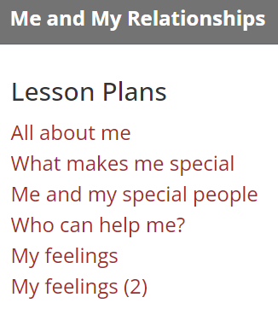  TRICK BOX: MIRROR MIRROR  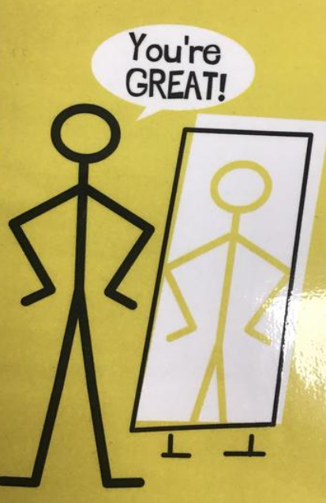 | Beginning to express their feelings and consider the perspectives of others.  Begin to take turns and share resources.  Independently choose where they would like to play.  Continue to build constructive and respectful relationships.  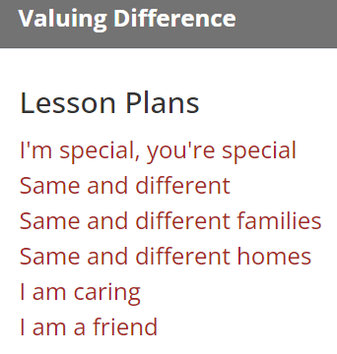  TRICK BOX: STAND TALL   |  | Show pride in achievements.  Understand behavioural expectations of the setting.  Can explain right from wrong and try to behave accordingly.  Manage their own needs.  Can identify kindness.  Seek others to share activities and experiences.  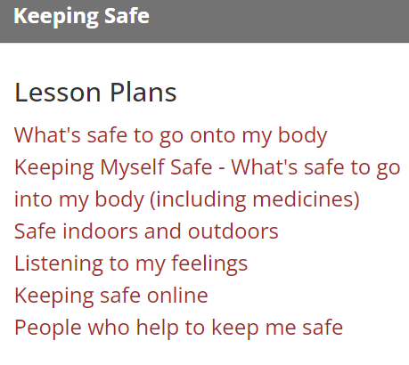  TRICK BOX: COLOUR BREATHING   |  | Can make choices and communicate what they need.  Begin to show persistence when faced with challenges.  Can keep play going by co-operating, listening, speaking, and explaining.  Can reflect on the work of others and self-evaluate their own work.  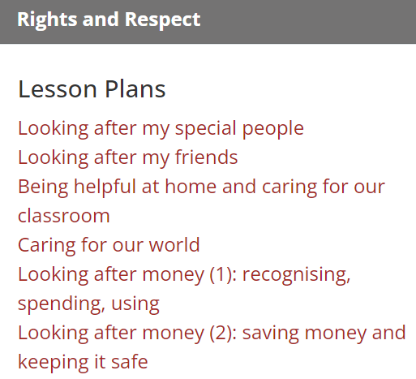  TRICK BOX: FLOATING CLOUD  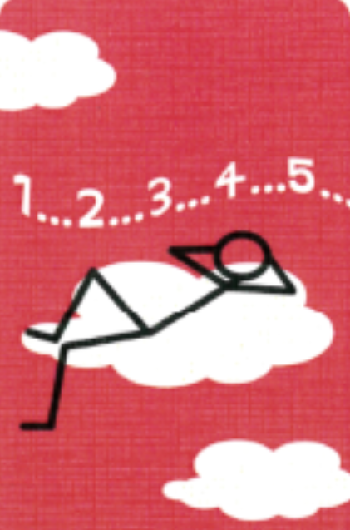 | Beginning to know that children think and respond in different ways to them.  Can talk about their own abilities positively.  Confident to try new activities  Show resilience and perseverance.  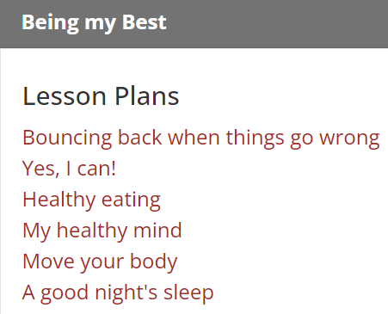  TRICK BOX: WIN WIN   | Able to identify and moderate own feelings.  See themselves as a unique and valued individual.  Can seek out a challenge and enjoy the process.  Show sensitivity to others’ needs and feelings.  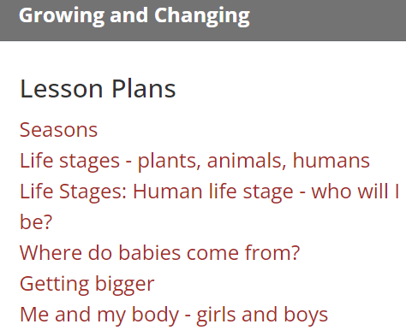  TRICK BOX: FREE FLOW  
Religious Education | The Emmanuel Project  Key Question:  Why is the word ‘God’ so important to Christians? | The Emmanuel Project  Key Question:  Why do Christians perform Nativity plays at Christmas? |  | The Emmanuel Project  Key question:  How can we help others when they need it? |  | The Emmanuel Project  Key Question:  Why do Christians put a cross in an Easter Garden? | The Emmanuel Project  Key question:  What makes a person really unique and precious? | The Emmanuel Project  Key Question:  How can we care for our wonderful world?
Physical Development   | Further develop the skills they need to manage the school day successfully: lining up and queuing, mealtimes, personal hygiene    Walking 1  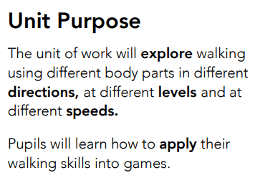    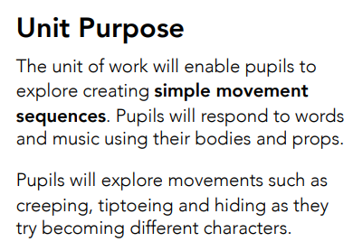 | Revise and refine the fundamental movement skills they have already acquired: rolling, crawling, walking, jumping, running, hopping, skipping, climbing.    Jumping 1  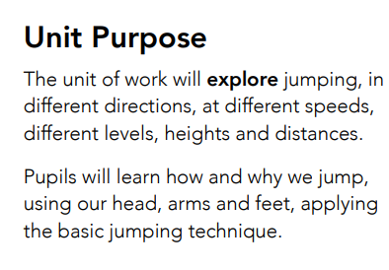    Hands 1  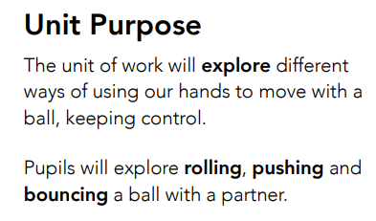 |  | Further develop and refine a range of ball skills including throwing, catching, kicking, passing, batting, and aiming.  Develop confidence, competence, precision, and accuracy when engaging in activities that involve a ball.    Moving  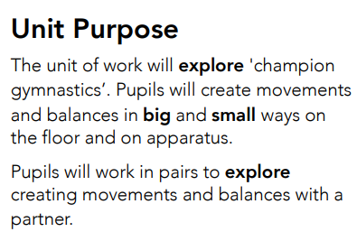    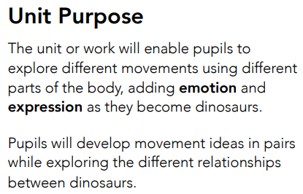 |  | Know and talk about the different factors that support their overall health and wellbeing: regular physical activity, healthy eating, toothbrushing, sensible amounts of ‘screen time’, having a good sleep routine, being a safe pedestrian.    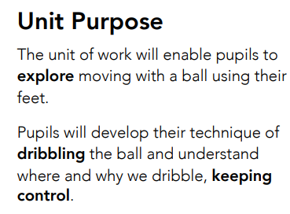    High, Low, Over and Under  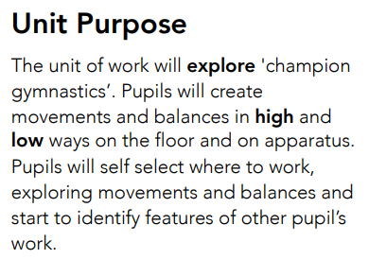 | Combine different movements with ease and fluency  Develop the foundations of a handwriting style which is fast, accurate and efficient.    Hands 2 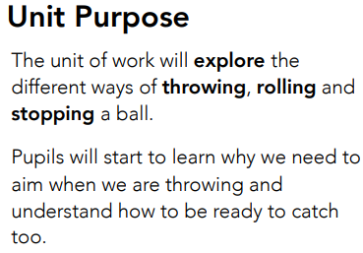    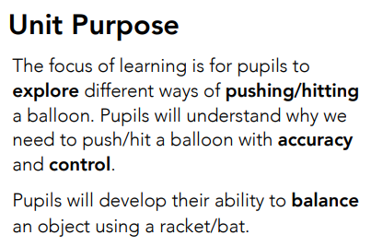 | Confidently and safely use a range of large and small apparatus indoors and outside, alone and in a group.    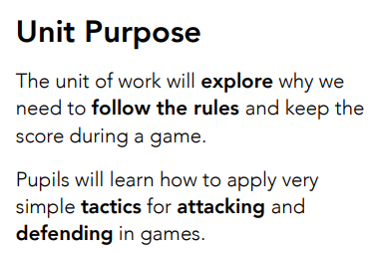  SPORTS DAY PRACTICE
Develop the overall body strength, co-ordination, balance, and agility needed to engage successfully with future physical education sessions and other physical disciplines including dance, gymnastics, sport, and swimming.
Develop their small motor skills so that they can use a range of tools competently, safely, and confidently. Suggested tools: pencils for drawing and writing, paintbrushes, scissors, knives, forks, and spoon.
Use their core muscle strength to achieve a good posture when sitting at a table or sitting on the floor.
Develop overall body-strength, balance, co-ordination, and agility.
Detailed fine motor development on ‘Physical Development’ skills plan.
Literacy   | Comprehension: Listen and enjoy sharing a range of books.  Hold a book correctly, handle with care.  Know that a book has a beginning and an end and can hold the book the right way up and turn some pages appropriately.  Know that text in English is read top to bottom and left to right.  Know the difference between text and illustrations.  Recognise some familiar words in print, e.g., own name or advertising logos.  Enjoy joining in with rhyme, songs and poems.  Explain in simple terms what is happening in a picture in a familiar story.  Complete a repeated refrain in a familiar rhyme, story or poem being read aloud. | Comprehension:  Experience and respond to different types of books, e.g., story books, factual/real-world books, rhyming and non-rhyming stories, realistic and fantasy stories.  Respond to ‘who’, ‘where’ ‘what’ and ‘when’ questions linked to text and illustrations.  Make simple inferences to answer yes/no questions about characters' emotions in a familiar picture book read aloud to them, with prompts.  Sequence two events from a familiar story, using puppets, pictures from book or role-play. |  | Comprehension: Use picture clues to help read a simple text.  Make a simple prediction based on the pictures or text of a straightforward story that is read aloud to them.  Show understanding of some words and phrases in a story that is read aloud to them.  Express a preference for a book, song or rhyme, from a limited selection.  Play is influenced by experience of books (small world, role play). |  | Comprehension: Retell stories in the correct sequence, draw on language patterns of stories.  With prompting, show understanding of many common words and phrases in a story that is read aloud to them.  Suggest how an unfamiliar story read aloud to them might end.  Give a simple opinion on a book they have read, when prompted.  Recognise repetition of words or phrases in a short passage of text.  Play influenced by experience of books  Innovate a well-known story with support. | Comprehension: Correctly sequence a story or event using pictures and/or captions.  Make simple, plausible suggestions about what will happen next in a book they are reading.  Know the difference between different types of texts (fiction, nonfiction, poetry)  Make inferences to answer a question beginning 'Why do you think…?' in a picture book that has been read to them, where answer is clearly signposted.  Play influenced by experience of books - gestures and actions used to act out a story, event or rhyme from text or illustrations. | Comprehension: Play influenced by experience of books - act out stories through role play activities, using simple props (e.g. hats, masks, clothes, etc.) and appropriate vocabulary. Innovate a known story.  Recall the main points in text in the correct sequence, using own words and include new vocabulary.  When prompted, say whether they liked or disliked a book, and give a simple justification or make a relevant comment.  With prompting, sometimes show understanding of some less familiar words and phrases in a story that is read aloud to them.
Literacy | Word Reading: Hear general sound discrimination and be able to orally blend and segment. | Word Reading: Read individual letters by saying the sounds for them.  Blend sounds into words, so that they can read short words made up of known letter-sound correspondences. Read common exception words matched to the school’s phonic programme. |  | Word Reading: Read individual letters by saying the sounds for them.  Blend sounds into words, so that they can read short words made up of known letter-sound correspondences.  Read common exception words matched to the school’s phonic programme. |  | Word Reading: Read some letter groups that each represent one sound and say sounds for them.  Read simple phrases and sentences made up of words with known letter–sound correspondences and, where necessary, some exception words. | Word Reading: Read some letter groups that each represent one sound and say sounds for them.  Read simple phrases and sentences made up of words with known letter–sound correspondences and, where necessary, an increasing number of exception words. | Word Reading: Read some tricky words from Phase 4 e.g. said, like, have, so.  Re-read what they have written to check that it makes sense.
 | Re-read books to build up their confidence in word reading, their fluency and their understanding and enjoyment. Read books consistent with their phonic knowledge.
Phonics | 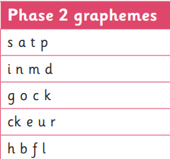  Tricky words: is, I, the | 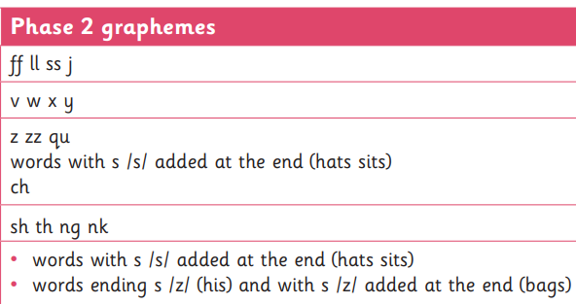  Tricky words: put, pull, full, as, and has, his, her, go, no, to, into, she, push, he, of we, me, be |  | 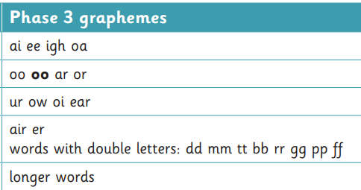  Tricky words: was, you, they, my, by, all, are, sure, pure |  | 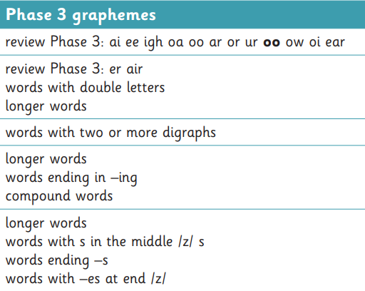  Tricky words: Revision of all covered. | 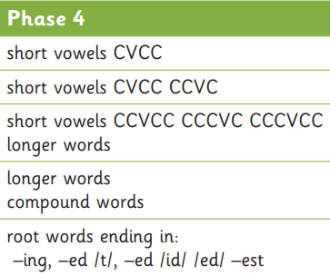  Tricky words: said, so, have like, some, come, love, do, were, here, little, says, there, when, what, one, out, today | 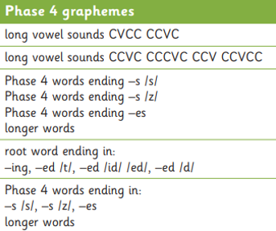  Revise all tricky words learnt.
Literacy | Emergent writing: Develop listening and speaking skills in a range of contexts. Aware that writing communicates meaning. Give meaning to marks they make. Understand that thoughts can be written down. Write their name copying it from a name card or try to write it from memory.  Composition: Use talk to organise describe events and experiences.  Spelling: Orally segment sounds in simple words.  Write their name copying it from a name card or try to write it from memory.  Handwriting: Know that print carries meaning and in English, is read from left to right and top to bottom.  Draws lines and circles. | Emergent writing: Copies adult writing behaviour e.g. writing on a whiteboard, writing messages. Makes make marks and drawings using increasing control. Know there is a sound/symbol relationship. Use some recognisable letters and own symbols. Write letters and strings, sometimes in clusters like words.  Composition: Use talk to link ideas, clarify thinking and feelings. Understands that thoughts and stories can be written down.  Spelling: Orally spell VC and CVC words by identifying the sounds.  Write own name.  Handwriting: Form letters from their name correctly. Recognise that after a word there is a space. |  | Emergent writing: Use appropriate letters for initial sounds.  Composition: Orally compose a sentence and hold it in memory before attempting to write it.  Spelling: Spell to write VC and CVC words independently using Phase 2 graphemes.  Handwriting: Shows a dominant hand. Write from left to right and top to bottom. Begin to form recognisable letters.  Handwriting N.B. The letters children can form correctly will relate to their name, phonics phases and other letters which children have been taught to form correctly) |  | Emergent writing: Build words using letter sounds in writing.  Composition: Orally compose a sentence and hold it in memory before attempting to write it and use simple conjunctions.  Spelling: Spell to write VC, CVC and CVCC words independently using Phase 2 and phase 3 graphemes.  Spell some irregular common (tricky) words e.g. the, to, no, go independently.  Handwriting: Holds a pencil effectively to form recognisable letters. Know how to form clear ascenders and descenders. | Emergent writing: Continue to build on knowledge of letter sounds to build words in writing. Use writing in play. Use familiar words in their writing.  Composition: Write a simple sentence with a full stop.  Spelling: Spell words by drawing on knowledge of known grapheme correspondences.  Make phonetically plausible attempts when writing more complex unknown words.  Handwriting: Form most lower-case letters correctly, starting and finishing in the right place, going the right way round and correctly orientated. Include spaces between words. | Emergent writing: Show awareness of the different audience for writing.  Write short sentences with words with known letter-sound correspondences using a capital letter and full stop  Composition: Write a simple narrative in short sentences with known letter-sound correspondences using a capital letter and full stop.  Write different text forms for different purposes (e.g. lists, stories, instructions.  Begin to discuss features of their own writing e.g. what kind of story have they written.  Spelling: Spell words by drawing on knowledge of known grapheme correspondences.  Make phonetically plausible attempts when writing more complex unknown words e.g. using Phase 4 CCVCC  Spell irregular common (tricky) words e.g., he, she, we, be, me independently.  Handwriting: Use a pencil confidently to write letters that can be clearly recognised and form some capital letters correctly.
Literacy Tree | 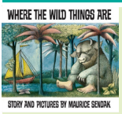  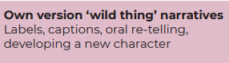 | 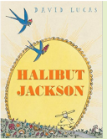  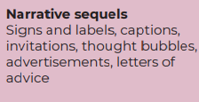  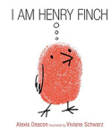  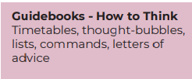 |  | 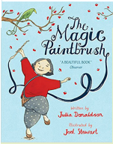  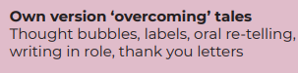  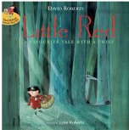   |  | 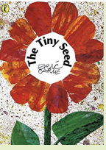  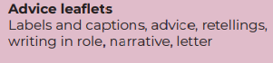  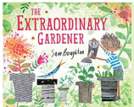  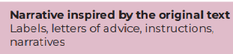 | 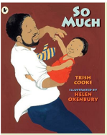  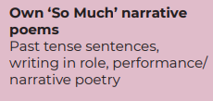  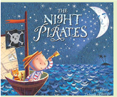  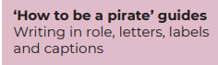 | 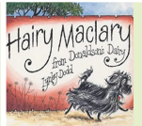  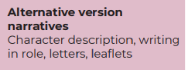  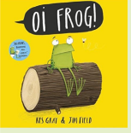  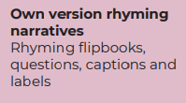
Mathematics   | Count objects, actions, and sounds.  Subitise  NCETM  SET 1  Subitising within 3  Counting, ordinality and cardinality. Focus on counting skills.  Composition of 3 and 4  Subtising objects and sounds  Comparison of sets  WHITE ROSE  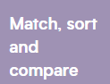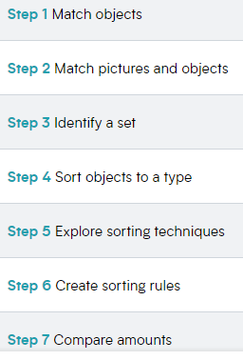 | Explore the composition of numbers to 10  Subitise  Automatic recall number bonds 0-10  NCETM  SET 2  Focus on the ‘fiveness of 5’ using one hand and the die pattern 5.  Comparison of sets by matching  Explore the concept ‘whole’ and ‘part’  Focus on the composition of 3,4,5  Practise object counting skills  WHITE ROSE  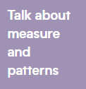 |  | Explore the composition of numbers to 10  Subitise  Automatic recall number bonds 0-10  NCETM  SET 3  Subitise within 5 focusing on die patterns.  Match numerals to quantities within 5.  Counting – focus on ordinality and the ‘staircase pattern.  Focus on 5  Focus on 6 and 7 as ‘5 and a bit’.  Compare sets and use language of comparison: more than, fewer than, an equal number to.  Make unequal sets equal.  WHITE ROSE |  | Explore the composition of numbers to 10  Subitise  Automatic recall number bonds 0-10  NCETM  SET 4  Focus on the ‘staircase’ pattern and ordering numbers.  Focus on ordering of numbers to 8.  Use language of less than.  Focus on 7  Doubles – explore how some numbers can be made of equal parts.  Sorting numbers according to attributes – odd and even numbers.  WHITE ROSE    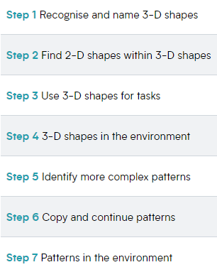 | Explore the composition of numbers beyond 10.  Subitise  Automatic recall number bonds 0-10  NCETM  SET 5  Counting – larger sets and things that cannot be seen.  Subitising – to 6, including in structured arrangements.  Composition – 5 and a bit.  Composition – of 10  Comparison – linked to ordinality.  Play track games.  WHITE ROSE  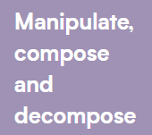  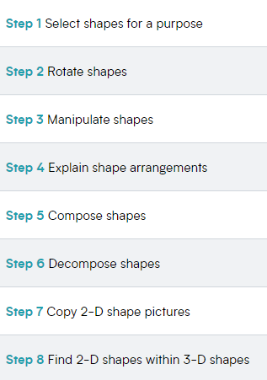 | Explore the composition of numbers beyond 10.  Subitise  Automatic recall number bonds 0-10  NCETM  SET 6  Subitise to 5  Introduce the rekenrek.  Automatic recall of bonds to 5 - review and assess.  Composition of numbers to 10 - review and assess.  Comparison- review and assess.  Number patterns - review and assess.  Counting - review and assess.  WHITE ROSE
 |  | 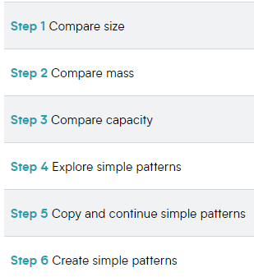  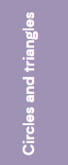  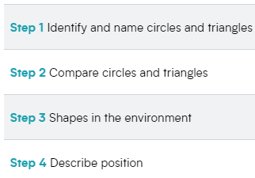 | 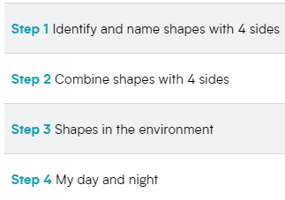 |   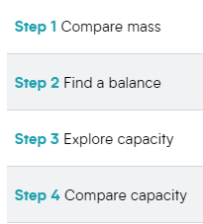 | 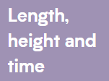  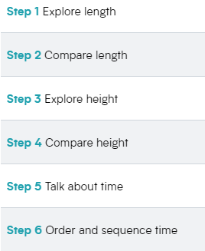 |  |  |   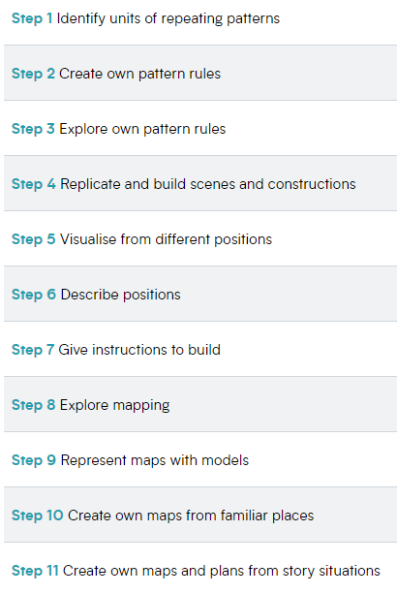 | 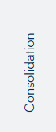
Ongoing throughout the year | Link the number symbol with its cardinal number value.  Count beyond ten. Compare numbers  Continue, copy, and create repeating patterns.  Compose and decompose shapes so that children recognise a shape can have other shapes within it, just as numbers can.  Select, rotate, and manipulate shapes to develop spatial reasoning skills.  Compare length, weight, and capacity.  Understand the ‘one more/one less than’ relationship between consecutive numbers.
Understanding the World   | Chronology: Talk about members of their immediate family and the relationship to them.  Name and describe people who are familiar to them. | Chronology: use the language of time when talking about past/present events in their own lives and in the lives of others including people they have learnt about through books.  Enquiry: Find out about key historical events and why and how we celebrate today? Remembrance Day, Christmas Day, Diwali. Ask questions, use different sources to find answers including books.  Comment on images of familiar situations in the past. |  | Chronology: Visually represent their own day on a simple timeline (correspond with number 7 work, days of the week) |  | Chronology: Talk about and understand changes in their own lifetime, by creating a personal timeline.  Enquiry: Describe images of familiar situations in the past using books. | Chronology: Recount an event, orally, pictorial and/or with captions.  Enquiry: Talk about key roles people have in society both in the present and past. Name and describe people who are familiar to them within their community e.g., police, fire service, doctors, dentist. | Chronology: Order experiences in relation to themselves and others, including stories.  Enquiry: Comment on images of familiar situations in the past. Describe features of objects, people, places at different times and make comparisons. Talk about what is the same and different.
 | Begin to develop a sense of continuity and change by being able to compare and contrast characters from stories throughout the year, including figures from the past. Using Little People, Big Dreams books.
 | Respect:  Themselves, special things in their own lives. | Respect:  Recognise that people have different beliefs and celebrate special times in different ways.  Recognise some similarities and differences between life in this country and life in other countries. |  | Respect:  Understand the value of being curious and interested in finding out about people within their own community and in other countries - special places and events or objects – through non-fiction texts, stories, visitors, celebrations. |  | Respect:  Understand the value of being curious and interested in finding out about people within their own community and in other countries - special places and events or objects – through non-fiction texts, stories, visitors, celebrations. | Respect:  Understand that some places are special to members of their community. | Respect:  Animals and know how to care for an animal/pets
 | TOPIC  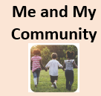  Recognise how they have changed from when they were babies.  Describe how they can look after their environment. Walk around the school.Talk to the children about everyday jobs that need doing in the classroom. These might include tidying the reading area or sweeping up the sand.  Talk about the different occupations that familiar adults and members of their community have.Talk about the people in their community who are key workers including delivery drivers and shop workers, and why this was important.  Name and talk about human-made features in the local environment.  Display aerial pictures, photographs of popular landmarks and maps of the local area. Encourage the children to explore the pictures and talk about places they recognise.  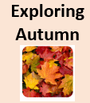  Explore the natural world around them and give simple descriptions, following observations, of changes. Arrange a woodland walk to look for signs that autumn is coming.  Provide leaves at various stages, including green leaves, ones that are changing colour, brown crispy leaves, decaying leaves and if possible leaf skeletons to explore. Understand that living things change over time.  Identify common features for different groups of animals, including wild and domestic animals.  With support observe, record and talk about materials and living things. Provide a selection of autumnal fruit and vegetables for the children to explore and discuss. | TOPIC    Explore and talk about pictures, stories and information books on the theme of royalty.  Explore and discuss similarities between aspects of their life and life in the past, using books, stories and pictures.  Explore the natural world around them and give simple descriptions, following observation, of changes.  Add bridge building resources to the construction area for the children to explore along with a range of additional resources. Include a selection of toy goats and a grumpy troll.  Add a range of cardboard boxes, tubes, 3-D shapes and decorations to the construction area for the children to build castles and fairy tale homes. Display the Fairy tale buildings picture cards to inspire their creative thinking.    Show an awareness of the similarities and differences between people in different communities and groups from around the world.  Christmas around the world.  Diwali and Hanukkah celebrations.  Explore and try a range of foods and suggest where they come from. Learn about Celebration food.  Name and sort everyday items into groups of the same material. Investigate is it shiny? |  | TOPIC  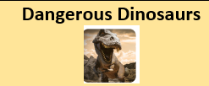  Represent scientific observations by mark making, drawing or creating simple charts and tables. Offer explanations for why things happen, making use of vocabulary, such as, because, then and next. Carnivore or herbivore.  Input simple instructions to technological toys, including floor robots and onscreen sprites. Make a 60x60cm card and divide it into 15cm squares. Draw a dinosaur island onto the grid and draw features in the squares, such as a swamp, volcano, lake and forest.  Resource the outside area with fabric, camouflage netting, crates and boxes for the children to make dinosaur islands. Add paper and pens for map making.  Investigation - Put a small dinosaur or prehistoric animal toy inside a balloon and fill with water and freeze. Remove the balloon and put the frozen egg in a tray and set the children the challenge of freeing the animal. Provide water sprays filled with warm water for the children to use.  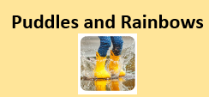  Describe simply how weather changes as the seasons change. Welly walk  Record observations about the way the local environment changes throughout each season. Record the weather.  With support, observe, record and talk about materials and living things. Is it waterproof? Investigation.  Set up a weather forecast, role play area with a large map of the United Kingdom and the Weather symbol cut outs.  Provide a variety of outdoor pinwheels, streamers, windsocks and windchimes for the children to explore on a windy day. |  | TOPIC    Observe and describe living things and their habitats within the local environment. Visit to local farm.  Care for growing seeds and plants and describe observable features of different types of plants and trees.  Name and describe basic features of plants and trees. Growing beans.  With support, observe, record and talk about materials and living things. Fill a tuff tray with various seeds to explore.  Match animals to their young.  Record data in simple tables, pictograms or block charts. ‘Which animal is the most popular?'  Put a range of fruit in a glass or clear plastic cloche. Leave it over time so the children can observe what happens to the fruit as it decays. Take photographs to document the changes.  Describe some similarities and differences between things in the past and the present. Farms in the past.  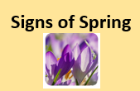  Record observations about the way the local environment changes throughout each season. Looking for signs of Spring.  Explore the natural world around them and give simple descriptions, following observation, of changes. Create a table display with the frogspawn or tadpole tank, hand lenses, the Frog life cycle picture cards.  Describe simply how weather changes as the seasons change. Rain or shine.  Begin to talk about and draw plants with attention to their parts. Spring flowering plants.  Cover a tabletop with feathers. Allow the children to handle the feathers and offer hand lenses for them to look closely at their shapes, colours and patterns.  Show an awareness of the similarities and differences between people in different communities and groups from around the world. Easter traditions.  Show an awareness of the similarities and differences between people in different communities and groups from around the world. Learning about the Holi festival. | TOPIC    Describe some ways that plants or animals should be cared for in order for them to survive. Looking after animals.  Make a shadow bigger or smaller using toys, play equipment and a light source. Put a length of paper in a sunny spot outside.  Identify common features for different groups of animals, including wild and domestic animals. Meet the animals.  Display the Scales, feathers and fur picture cards alongside a variety of feathers, furry and scaly fabric for the children to explore and discuss. Ask the question, 'How do you think the animals feel?' Scales, fur and feathers.  Match animals to their young. Display the Animals and their babies picture cards for the children to explore and match together.  With support, observe, record and talk about materials and living things. Longest, shortest, tallest  Describe how the weather, plants and animals of one place is different to another using simple geographical terms. Animals around the world.  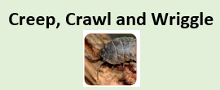  Observe and describe living things and their habitats within the local environment. Minibeast Safari  Represent scientific observations by mark making, drawing or creating simple charts and tables. Offer explanations for why things happen, making use of vocabulary, such as, because, then and next. Looking after nature.  Identify common features for different groups of animals, including wild and domestic animals. Same and different.  Display the Minibeast picture cards, paper, drawing resources and the Minibeast word mat. Challenge the children to draw a minibeast and label its body parts.  Make a wormery.  Set up a bee investigation station with the Bee picture cards, books, leaflets and posters on the theme of bees. You could even offer toast and honey for the children to try.  Plant wildflowers and create a wild garden area for the children to explore. Which animals come to visit the garden? | TOPIC  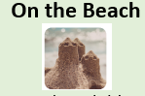  With support, observe, record and talk about materials and living things.Molluscs such as snails, clams and muscles have shells to protect them.  Name a variety of domestic and wild animals. Learn about animals including sea birds, crabs and starfish live at the sea shore.  Identify common features for different groups of animals, including wild and domestic animals. Learning that crabs have five pairs of legs. The first pair of legs has pincers.  Investigate rockpools and learn who they are habitats for.  Animals eat different kinds of food, including other animals, plants or both animals and plants.  Who lives in the ocean?  Some animals including fish, whales, sharks and dolphins live in the seas and oceans. Learning about features of fishes.  Begin to notice and talk about the different places around the world, including oceans and seas. Looking after our beach.  Holidays in the past.    Talk about the different occupations that familiar adults and members of their community have.  Display books on the theme of sporting heroes and provide a tablet or computer with clips of famous sports people competing in their events for the children to watch.  Does it bounce? Investigation  Provide a range of balls and display two hoops labelled 'bouncy' and 'not bouncy'. Invite the children to test and sort the balls. Can they predict which ones will bounce and explain why?  Shadows. Make a shadow bigger or smaller using toys, play equipment and a light source.
Expressive Arts and Design   | TOPIC  Sing well-known songs and nursery rhymes in a group or on their own, increasingly matching the pitch and following a melody.  Mixing 2 colours together.Offer trays of primary coloured, ready-mixed paints with a range of loose parts for printing fun.  Explore, build and play with a range of resources and construction kits. Provide paper and drawing resources for the children to draw their creations or draw pictures of the emergency vehicles.  Use natural materials and loose parts to make 2-D and 3-D art. Provide a selection of leaves, hole punches, threads, ribbons and thick needles. Invite the children to make leaf decorations or autumn garlands.  Provide materials, such as conkers, googly eyes, stick on feet, pipe cleaners and twigs with which the children can create pictures.  Provide a basket of pine cones and coloured elastic bands for wrapping, twisting and layering.  Construct a large weaving frame using garden netting on a fence. Provide a variety of autumn-themed fabric strips and natural resources for weaving and threading.  Sing up  I’ve got a grumpy face  Musical focus  • Timbre  • Beat  • Pitch contour  Songs  • I’ve got a grumpy face  • Happy  The sorcerer’s apprentice  Musical focus  • Musical storytelling  •Louder/quieter  • Faster/slower  • Higher/lower  • Timbre  Songs  • Alice the camel  Develop storylines in their pretend play. | TOPIC  Provide props from the story of Goldilocks for the children to use to retell and act out the story.  Provide a good range of building materials for the children to explore and challenge the children to make dens or houses for the pigs.  Provide royal dressing up clothes for the children to role play and use their creations as props within their play.  Wrap wooden blocks in shiny paper or foil and add shiny resources to the construction area for building fun.  Celebration art.  Sing up  Witch, witch  Musical focus  • Call-andresponse  • Pitch (la-so-mi-do)  • Timbre  Songs  • Witch, witch  Row, row, row your boat  Musical focus  • Beat  • Pitch (step/leap)  • Timbre  Songs  • Row, row, row your boat  • The transport song  Sing in a group or on their own, increasingly matching the pitch and following the melody. |  | TOPIC  Set up a dinosaur hunt obstacle course in the outside area for the children to explore, using large log slices, crates and tunnels. You could even chalk a river for the children to cross on their journey.  Provide the children with paper plates, green card, split pins, scissors, shades of green paper, green cellophane and glue to make paper plate turtles.  Use natural materials and loose parts to make 2-D and 3-D art. Mud painting.  Create collaboratively, share ideas and use a variety of resources to make products inspired by existing products, stories or their own ideas, interests or experiences. Add dinosaur eggs to the sand.  Share their creations with others, explaining their intentions and the techniques and tools they used. Dinosaur painting.  Use primary and other coloured paint and a range of methods of application. Printing with plastic dinosaurs.  Junk model dinosaurs.  Use a variety of percussion instruments, along with the children's rainsticks, to explore making rain music. Provide tablets or other audio recording equipment for the children to record the sounds that they make.  Offer coloured chunky chalks and spray bottles for the children to make brightly-coloured pictures. They could draw around puddles or spray water onto the chalk pictures to see how the colours change.  Adapt and refine their work as they are constructing and making. Making dens.  Use primary and other coloured paint and a range of methods of application. Colour match.  Display a variety of coloured building bricks and blocks for the children to make houses and buildings. Provide large rolls of paper and colourful pens for the children to draw streets and roads. Add small world people for the children to introduce a storyline to their play.  Sing up  Birdspotting: Cuckoo polka  Musical focus  • Active listening  • Beat  • Pitch (so-mi)  • Vocal play  Shake my sillies out  Musical focus  • Timbre  • Pitch (higher/ lower)  • Tempo (faster/ slower)  Songs  • Shake my sillies out  Return to and build on their previous learning, refining ideas and developing their ability to represent them. |  | TOPIC  Learning farm songs  Explore colour and application of paint using a range of different tools. Fruit art  Adapt and refine their work as they are constructing and making. Make seed shakers.  Collaged farms from aerial pictures. Looking Down  Explore artwork by famous artists and talk about their likes and dislikes. Giuseppe Arcimboldo – pictures in the style of.  Select appropriate materials when constructing and making. Making nests.  Listen to a variety of music, rhymes and songs, paying attention to how they sound and sharing their opinions. Music time  Display daffodils at different stages with some in bud, and some in full bloom. Cut one of the daffodils in half so the children can see inside the flower. Provide hand lenses for the children to explore the daffodils.  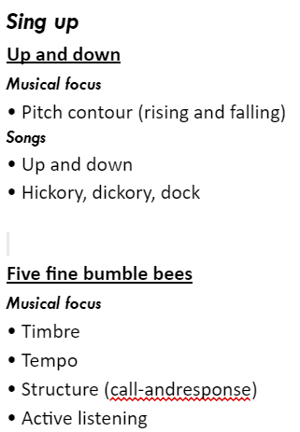  Songs  • Five fine bumble bees  Create collaboratively sharing ideas, resources, and skills. | TOPIC  Communicate their ideas as they are creating artwork. Feathered friends.  Discuss similarities and differences in their own and others' work, linked to visual elements, such as colour, scale, subject matter, composition and type. Animal patterns.  Rainforest animals.  Display the Animal mask templates with different coloured fabric capes or tabards for the children to dress up and act out a role or create animal stories in their play. The children might like to wear the masks they made as they play.  Create collaboratively, share ideas and use a variety of resources to make products inspired by existing products, stories or their own ideas, interests or experiences. Animal homes.  Set up large weaving frames outdoors on railings or use old bicycle wheels. Offer coloured wool and floristry ribbon for the children to weave and create patterns. Wonderful webs  Butterfly printing  Display the Butterfly picture cards, Butterfly templates, a selection of leaves, flower petals and glue for the children to create symmetrical butterflies using the natural resources.  Use primary and other coloured paint and a range of methods of application. Add oval-shaped pebbles and ready-mixed paint in the creative area for the children to make minibeast pebble art.  Provide play dough, googly eyes, matchsticks, pipe cleaners and craft pompoms for the children to create model minibeasts.  Add small world worms, millipedes and centipedes to damp sand. Offer twigs, leaves, small rocks and log slices and challenge the children to make tunnels and dens for the creatures.  Explore artwork by famous artists and talk about their likes and dislikes. The Snail by Henri Matisse. Making collaged snails.  Sing up  It’s oh so quiet!  Musical focus  • Dynamics  • Timbre  • Musical storytelling  Songs  • Pass the secret round  • Bang my drum  Slap clap clap  Musical focus  • Music in 3-time  • Beat  Songs  • Slap clap clap  Listen attentively, move to, and talk about music, expressing their feelings and responses. | TOPIC  Beach art. Use digital devices to take digital images or recordings of their creations to share with others.  Sounds of the sea.  Sandy paint.  Learn and sing songs and rhymes as part of a larger group.  Roll it. Use primary and other coloured paint and a range of methods of application.  Create collaboratively, share ideas and use a variety of resources to make products inspired by existing products, stories or their own ideas, interests or experiences. Add hydrated water beads to the water tray.  Sing up  Down there under the sea  Musical focus  • Timbre  • Structure  • Active listening  • Tune moving in step  • Soundscape  Songs  • Down there under the sea  Bow, bow, bow Belinda  Musical focus  • Beat  • Active listening  • Accompaniment  Songs  • Bow, bow, bow Belinda  Watch and talk about dance and performance art, expressing their feelings and responses.
Explore, use, and refine a variety of artistic effects to express their ideas and feelings
Explore and engage in music making and dance, performing solo or in groups. Singing – well known nursery rhymes, familiar songs and chants.

Spirituality in EYFS
 | 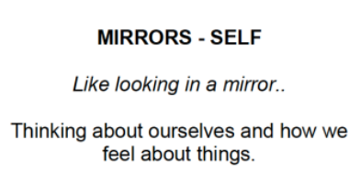   | 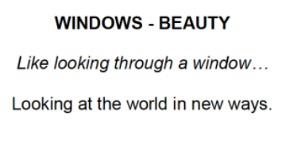  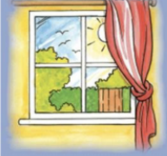 | 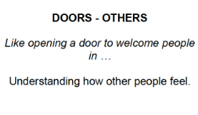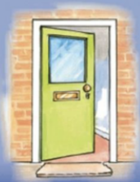 | 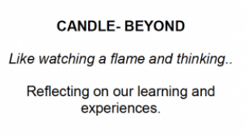  
Knowledge Aspect | - Understanding I am a unique person  - Have a perception of myself  - Having self-worth  - Having values and beliefs that are my own  - Having self confidence  - Feeling joy, fulfilment, peace, patience, freedom, humility, integrity and creativity  - Having my own identity  - Being able to make decisions and take responsibility  - Feeling joy and celebrating achievements  - Being able to be silent and reflect | - Have awe and wonder about the world  - See the beauty relating to the man-made and natural world  - Have care and consideration towards nature  - Connect with nature  - Value nature and creation  - Be curious and inquisitive about the world around them  - Ask big questions about life  - Have a sense of mystery  - Have an open mindedness to life | - Having empathy, concern, compassion and forgiveness for others  - Appreciating and understanding others values, opinions, principles and beliefs  - Caring and nurturing approach to others  - Being able to create inter-personal relationships  - Be able to feel love, hope and trust  - Be able to follow the values of my school community  - Enjoy and engage in celebrations  - See others as feeling thinking beings  - Have an awareness of failure, loss, disappointment, suffering and pain of others | - Be able to understand meaning outside of everyday life  - Have faith in religion  - Have adoration and worship  - Be at one with the creator  - Have an essence of the universe  - Understand that there is more to life than meets the eye
How do we encourage Spirituality? | - Reflecting on their own beliefs through collective worships and RE activities and lessons.  - Discussions and conversations in class, with adults and with peers  - Reflection on their own experiences  - Celebrations of success within and outside of the school community  - Through visitors, trips and clubs  - Half termly values  - Prayer space  - Providing children with good role models from all adults in school  - Promoting positive, considerate, kind attitudes by all adults in school.  - Recognising the backgrounds and individual needs of all children in school  - Behaviour choices and encouraging children to make the right decisions | - Curriculum; through learning about the world in multiple subject areas  - Collective worships  - Community projects both internal and external (Recycling)  - Real life experiences | - Working with and raising money for charities  - Collective worships  - Celebration assemblies  - Curriculum subjects and activities  - Half termly values  - Prayer space  - Community links- project outcomes and links with local groups  - Creating links with parents to encourage a home/school partnership  - Children can conduct themselves appropriately amongst each other  - Discussion of real world events and news. | - Collective worship  - Links with the vicar  - Real life experiences  - Have candles for collective worship (During Hall Collective Worships)  - Prayer  - Reflection

