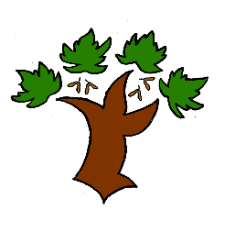
Puddletown First School
KS1 Art and Design – Achieving Mastery

At Puddletown First School we understand the National Curriculum to be a mastery curriculum. We believe to show mastery of the Geography curriculum children need to be able to demonstrate key skills or concepts independently. The principle behind achieving mastery in the children being able to demonstrate an ability ‘to think like an artist or designer’
Curriculum intent:
- Produce creative work through exploring their ideas and experiences
- To become proficient in drawing, painting, sculpture and other art and design techniques
- Evaluate and analyse creative works using the appropriate vocabulary
- Know about famous artists and understand the development of art forms
- Use a range of materials to creatively design and make products
- Use drawing, painting and sculpture to share their ideas and imagination
- To be able to use line, colour, texture, pattern, form and space in their work
- Know about some famous artists and designers and describe some differences between their work as well as making links to their own work
Artists and designers to be followed

Key vocabulary

