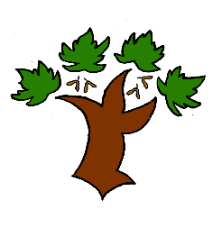**Puddletown First School**

**KS1 Science– Achieving Mastery**

At Puddletown First School we understand the National Curriculum to be a mastery curriculum. We believe to show mastery of the Geography curriculum children need to be able to demonstrate key skills or concepts independently. The principle behind achieving mastery in the children being able to demonstrate an ability *‘to think like a scientist’*

**Curriculum intent:**

* To develop scientific knowledge and understanding through enquiry and observation
* To carry out a scientific enquiry answering a question about the world around them employing scientific methods and processes
* Show an understanding of how some science is used in the world they live

**Working scientifically**

* Ask simple questions and recognise that they can be answered in different ways
* Set up simple requiring observations and measurements that help answer questions
* Use observations to suggest answers
* Identify and classify according to observable features

**Living things**

* Observe and describe how seeds grow
* Find out and know what a plant needs to grow healthily
* Know that animals have offspring that grow to adults
* Know the basic needs of animals and humans and what a healthy human lifestyle is
* Understand a basic food chain
* Identify that animals live in a habitat to which they are suited, develop an understanding of an ecosystem

**Materials**

* Identify and compare the suitability of everyday materials
* Find out how some solid shapes can be changes by a force (ie stretching, squashing etc)

**Key vocabulary**