Literacy and Reading: We will be learning new sounds each week in our daily phonics lessons. These will be sent home each week on a Friday in their red scrapbook so that you can practise them at home. We will also learn to read tricky words (words that cannot be phonetically decoded), to help read exception words we will look for the part of the word that is tricky and does not for the phonic rules. We will practise this during daily phonics lessons and guided reading lessons. When guided reading we will focus on decoding, prosody (reading with expression) and comprehension. Each week children will bring home a library book to share and enjoy with you and their guided reading book to practise at home.  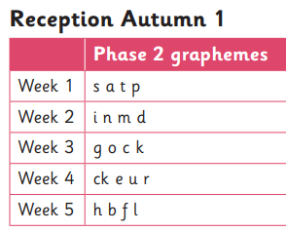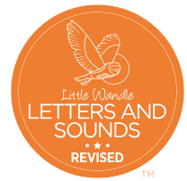  Tricky words – is, I, the | Mathematics:  In Maths we will be using NCETM for the number aspect of our learning and the White Rose Scheme for our topic Maths.    Week 1 – Subitising within 3  Week 2 – Counting, ordinality and cardinality. Focusing on counting skills.  Week 3 – Composition. Exploring how all numbers are made in 1’s. Focus on composition of 3 and 4  Week 4 – Subitising. Subitise objects and sounds  Week 5 – Comparison. Comparison of sets – ‘just by looking’. Use the language of comparison: more than and fewer than.    Week 6 – Match, sort and Compare. Match pictures and objects, identify a set. | Understanding the World:  We will be learning about how the children have changed from when they were babies. The children will learn about how they can look after their environment. They will walk around the school and think about how to look after their classroom. We will talking about the different occupations that familiar adults and members of their community have. We will talk about the people in their community who are key workers including delivery drivers and shop workers, and why this was important. We will name and talk about human-made features in the local environment. We will look at aerial pictures, photographs of popular landmarks and maps of the local area. The children will be encouraged to explore the pictures and talk about places they recognise.  
Communication and Language:  Children will be learning how to listen carefully and why listening is important. They will engage in story times, rhymes and songs. They will be learning to maintain attention in whole class and groups.  In English we will be looking at the book ‘Where the wild things are’ by Maurice Sendak. Whist looking at this book the children discover some footprints and a clump of fur: who – or what- has been in class? Then they find Sam’s Sack, which is filled with objects beginning with the letter ‘s’. The classic text Where the Wild Things Are is shared and then, through song, roleplay and activities such as Monster Meet and Greet, the children devise their own Wild Thing characters to create their own version of the story.  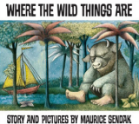 | Reception Autumn Term 1 | PSHE:  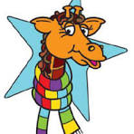  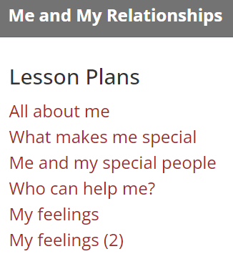

Me and My Community Exploring Autumn
 | Physical Development:  The children will further develop the skills they need to manage the school day successfully: lining up and queuing, mealtimes, personal hygiene  PE:  Walking 1; Mr Treble will be taking PE every Friday. This unit focuses on walking using different body parts, in different directions, at different levels and at different speeds.  Dance; Mrs Flux will teach dance every Tuesday based on ‘Ourselves’. This will enable pupils to create simple movement sequences. Pupils will respond to words and music using their bodies and props.  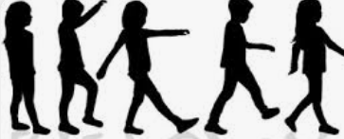 | RE:  Emmanuel Project  ‘Why is the word God so important to  Christians?’ lays foundations for  understanding the Christian belief that the  universe is not random but the creation of a  holy God, who designed and gave life and  purpose to our world. ‘God’ is therefore an  important and significant name for believers.  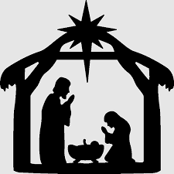  Within this unit the children will also be introduced to the Muslim faith and find out about how God is important to them.  
Expressive Arts and Design:
The children will be learning to sing well-known songs and nursery rhymes
in a group or on their own, increasingly matching the pitch and following a melody. They will be mixing 2 colours together. They will be offered trays of primary coloured, ready-mixed paints with a range of loose parts for printing fun.
The children will be exploring, building and playing with a range of resources and construction kits. The children can draw their creations or draw pictures of the emergency vehicles they make. They can use natural materials and loose parts to make 2-D and 3-D art. Children will be provided with materials, such as conkers, googly eyes, stick on feet, pipe cleaners and twigs with which the children can create pictures.
In Music we follow the programme ‘Sing up’ This term we will be exploring timbre, beat, pitch contour, louder/quieter, faster/ slower and ‘higher and lower.
