Literacy and Reading:  We will be learning new sounds each week in our daily phonics lessons. These will be sent home each week on a Friday in their red scrapbook so that you can practise them at home. We will also learn to read tricky words (words that cannot be phonetically decoded), to help read exception words we will look for the part of the word that is tricky and does not for the phonic rules. We will practise this during daily phonics lessons and guided reading lessons. When guided reading we will focus on decoding, prosody (reading with expression) and comprehension. Each week children will bring home a library book to share and enjoy with you and their guided reading book to  practise at home.  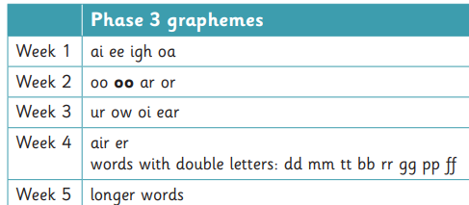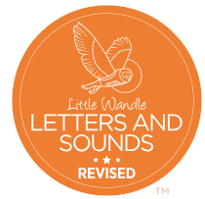  Tricky words – was, you, they, my, by, all, are, sure, pure | Mathematics:  In Maths we will be using NCETM for the number aspect of our learning and the White Rose Scheme for our topic Maths.    Week 1 – Subitising  Week 2 – Counting, ordinality and cardinality.  Week 3 – Composition.  Week 4 – Composition  Week 5 _ Comparison    Alive in 5  Mass and capacity  Growing 6, 7, 8  Length, Height and Time | Understanding the World:  Represent scientific observations by mark making, drawing or creating simple charts and tables. Offer explanations for why things happen, making use of vocabulary, such as, because, then and next. Investigate the meaning of Carnivore or herbivore.  Input simple instructions to technological toys, including floor robots and onscreen sprites.  Resource the outside area with fabric, camouflage netting, crates and boxes for the children to make dinosaur islands. Add paper and pens for map making.  Investigation - Put a small dinosaur or prehistoric animal toy inside a balloon and fill with water and freeze. Remove the balloon and put the frozen egg in a tray and set the children the challenge of freeing the animal. Provide water sprays filled with warm water for the children to use.  Describe simply how weather changes as the seasons change. Welly walk.  Record observations about the way the local environment changes throughout each season. Record the weather.  Is it waterproof? Investigation..
Communication and Language:  Children will be learning how to listen carefully and why listening is important. They will engage in story times, rhymes and songs. They will be learning to maintain attention in whole class and groups.  In English we will be looking at the book ‘The Girl and the Dinosaur’ by Hollie Hughes. This is the story of a little girl called Marianne who digs for dinosaur bones on a golden, sandy beach. That night, she makes a wish on the wishing star for the bones to come to life. Her dream comes true, and Marianne and the dinosaur go off to a magical, moonlit island. There, they meet other children and creatures from their dreams. It is a land 'where anything is possible, and nothing's as it seems'.  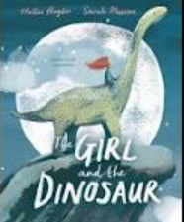 | Reception Spring Term 1 | PSHE:  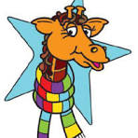  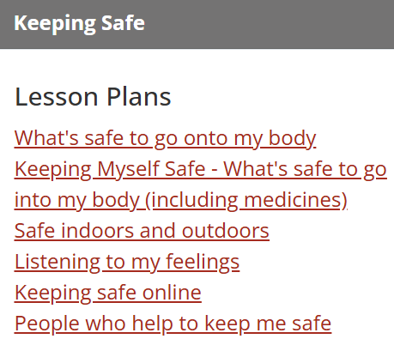

Dangerous Dinosaurs Puddles and Rainbows

 | Physical Development:  The children will further develop the skills they need to manage the school day successfully: lining up and queuing, mealtimes, personal hygiene  PE:  Gymnastics - Moving ; Mr Treble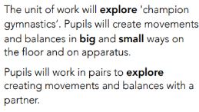 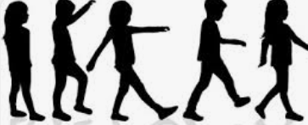  Dance - Dinosaurs ; Holly 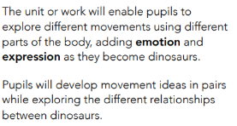  | RE:  Emmanuel Project  How can we help others when they need it?  lays foundations for understanding the Christian belief that God came to earth in Jesus, to rescue humans from their failings and wrongs, and to call his followers to love and help all in need just like  him. Jesus’ name actually means ‘saviour’ or ‘rescuer’, someone who helps others in real need. Jesus paid the ultimate price by dying for  others and, even for humans, helping can be costly and requires collaboration. The unit also offers pointers to what another faith teaches.  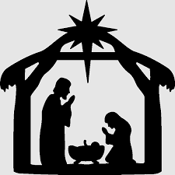  
Expressive Arts and Design:
A dinosaur hunt obstacle course in the outside area for the children to explore, using large log slices, crates and tunnels. Dinosaur collage.
Use natural materials and loose parts to make 2-D and 3-D art. Mud painting.
Create collaboratively, share ideas and use a variety of resources to make products inspired by existing products, stories or their own ideas, interests or experiences.
Add dinosaur eggs to the sand. Share their creations with others, explaining their intentions and the techniques and tools they used.
Dinosaur painting. Printing with plastic dinosaurs.
Junk model dinosaurs.
Offer coloured chunky chalks and spray bottles for the children to make brightly-coloured pictures. They could draw around puddles or spray water onto the chalk pictures to see how the colours change.
Use primary and other coloured paint and a range of methods of application. Colour match.
Display a variety of coloured building bricks and blocks for the children to make houses and buildings. Provide large rolls of paper and colourful pens for the children to draw streets and roads. Add small world people for the children to introduce a storyline to their play.

In Music we follow the programme ‘Sing up’ Bird spotting and Shake my sillies out’ This term we will be active listening, beat, pitch (so-mi), vocal play.
and Timbre, pitch (higher/lower), tempo (faster/slower), beat.
