PUDDLETOWN VC CE FIRST SCHOOL NEWSLETTER

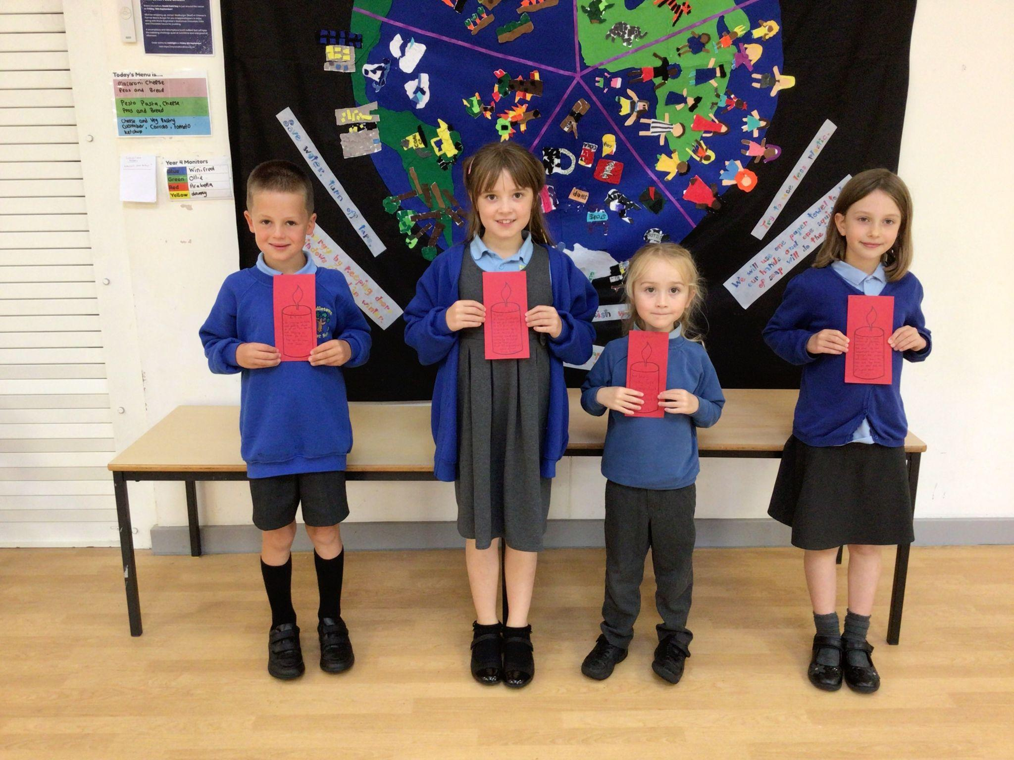 | 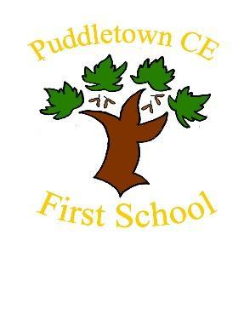
 | September 2024
WELCOME BACK | REMINDERS
How lovely to see you all back at school having enjoyed your summer breaks. The children all looked so smart in their uniforms and were proudly showing me their new shiny shoes. They were so excited to start in their new classes, be with their new teachers and play with their friends again. We have had a fantastic week and a great start to the new school year.  A special warm welcome to our new parents - thank you for choosing our school and I am sure that you and your children will develop many friendships and happy memories of your time here. Our wonderful new reception class has settled quickly and the children are already developing friendships and learning about school life. They all had a school tour and came to visit me in my office where we had a lot of fun trying out my chairs and looking at my ‘wonderful work wall’ which is where I display special work from the children. I look forward to getting to know them all.  The best place to park when dropping off your children is in the ‘rec’ opposite the school which helps keep disruption to our village residents to a minimum. We appreciate thoughtful parking.  There are many exciting events planned for the children this term and the best place to find dates is on our website calendar. We have had an IT upgrade over the summer and our new website is nearly ready. I will let you know when it goes ‘live’.  Our photo this week is of our very first shining lights award winners. This is a weekly award for one pupil in each class who has gone over and above to demonstrate our church school values of responsibility, forgiveness, acceptance and justice. Well done to our very first 4 who have already shown us what great role models for the school they are.  If you have any queries or concerns contact the office who will direct your email to the right person to help you.  We are all looking forward to a fantastic term filled with learning and fun.  Mrs Anna Seal Head of school | In years 3 and 4 the government no longer supplies free fruit at breaks so please ensure you send your child in with a healthy snack. No sweets, chocolate or crisps please.  Please ensure your child brings in their book bag every day with their reading book, record and any work needed.  The school gates open at 8.30 for before school play. If your child doesn’t want to do that then bring them at 8.40 which is when they go into class. Gates close at 8.45. Please ensure your child is in school by then. Pick up is at 3:15 from your child’s classroom.

