

Puddletown Church of England VC First School
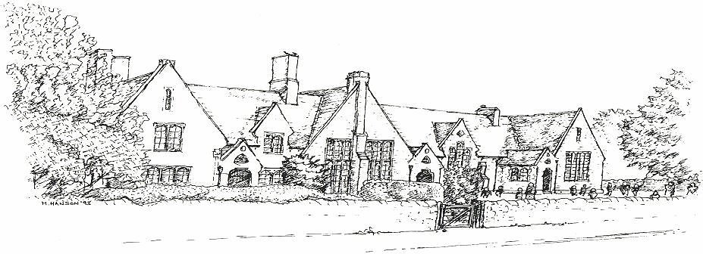









Parents do not have a right to take their children out of school for holidays during term time. By law you must ask permission for your child to miss school. First Schools and the Middle School in the Puddletown St Mary’s mini pyramid have agreed to follow a common policy on holiday absence, but it is up to the headteacher of your school to decide whether or not the absence will be authorised. Children’s present attendance levels will be taken into account when making a decision. Further details as to the school’s policy for authorising ‘holidays in term time’ are available on the school website or from the School office

Parents wishing to apply for their child to have leave from school should complete this form and return it to school for authorisation well in advance of the proposed leave.

To be completed by parent/guardian
Surname of child |  | First name
Date of birth |  | Class
Surname of parent/guardian |  | First name
Address
Telephone number
Length of absence (school days) |  | From  (date) |  | To  (date)
Reason for absence request
Would (s)he miss any national assessments during the months of May and June? |  |  |  |  | Yes/no
Is the proposed absence during the month of September? |  |  |  |  | Yes/no
Would (s)he be absent for more than ten school days? |  |  |  |  | Yes/no
Has (s)he already had leave during term-time this school year?  (If so, please give dates and number of school days leave) |  |  |  |  | Yes/no
Did (s)he have leave of absence for holiday during term-time in the previous school year? |  |  |  |  | Yes/no

To be completed by school
Child’s current attendance, over previous 12 month period.  (to be completed by school) |  | %
Is his/her attendance already below 90% for the previous  12 month period? |  | Yes/no
Holiday in Term Time | (i) approved school days  (ii) not approved school days
Date of Meeting with Parent

