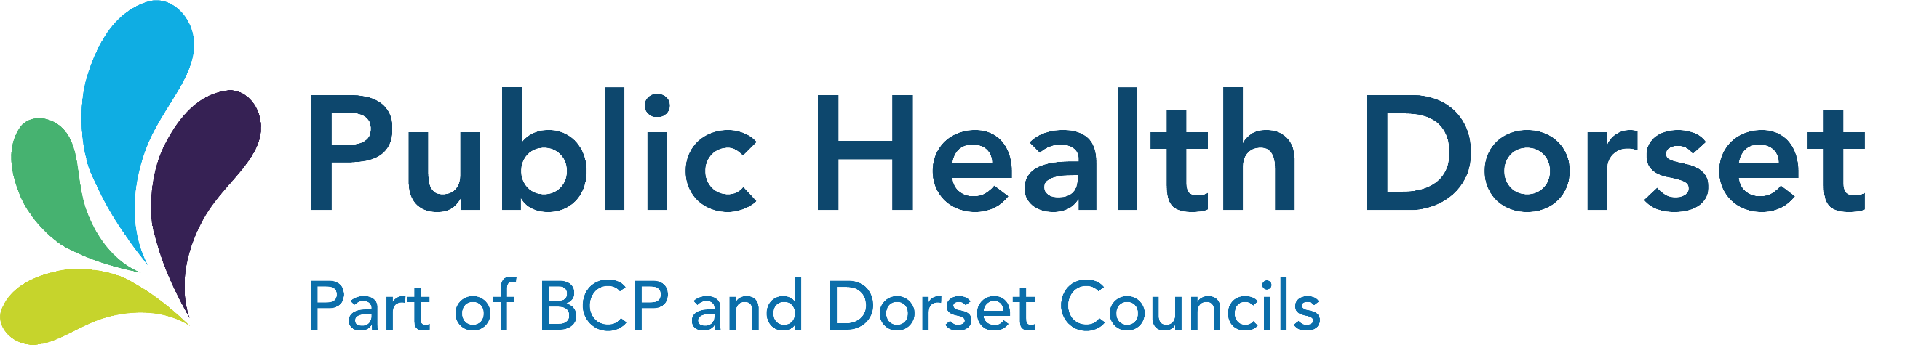
County Hall, Colliton Park
Dorchester
Dorset
DT1 1XJ
Public Health Dorset: 01305 224400

Children and Young People Public Health Service (school nursing)
Pan-Dorset contact number: 01929557558
https://www.dorsethealthcare.nhs.uk/school-nursing

Dear Parent/ Carer

National Child Measurement Programme (NCMP)

Height and weight checks for children in Reception and Year 6

What is the NCMP?
Each year in England, school children in Reception and Year 6 have their height and weight checked at school as part of the National Child Measurement Programme. Height and weight measurements are used to calculate weight status.

Your child’s class will take part in this year’s programme.

The checks are carried out by registered school nurses or trained health care providers. Children are measured fully clothed, except for their coats and shoes, in a private space away from other pupils. The programme will be delivered in line with the school and local authority’s safety control measures.

Further information about the National Child Measurement Programme can be found at https://www.nhs.uk/live-well/healthy-weight/national-child-measurement-programme

Information and fun ideas to help your children stay healthy can be found at https://www.nhs.uk/healthier-families/ or sign up for the 8-week NHS Healthy Steps email programme. You will be sent lots of low-cost easy tips, fun games, healthy swaps and tasty recipes on a budget.

Information about talking to your child about healthy weight is available at:
https://www.bath.ac.uk/publications/talking-to-your-child-about-weight-a-guide-for-parents-and-caregivers-of-children-aged-4-11-years/

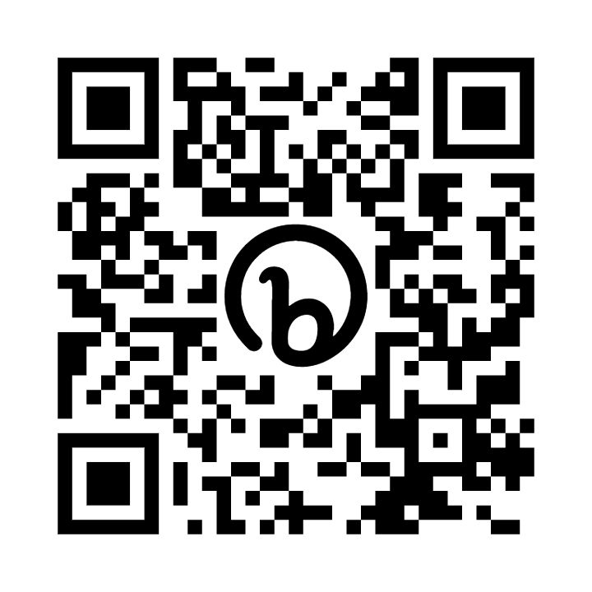

Scan the QR code or visit https://healthysteps.betterhealth-healthierfamilies.co.uk/signup

The information we collect and why we do
Name, date of birth and NHS Number are collected to link your child’s measurements between when taken in Reception and then again in Year 6.

Date of measurement, sex and date of birth are used to calculate your child’s weight category

Other data sets held by NHS Digital and Department of Health and Social Care may also be linked as this would let us add information from health and education records, where lawful to do so, to understand how and why the weight of children is changing, and how this affects children’s health and education Linking information in this way helps us to understand how and why the weight status of children is changing, and how this affects children’s health. All the data collected is also used for improving health, care and services through research and planning.

All this information is treated confidentially and held securely.

Ethnicity and address are used to help understand some of the reasons for the difference and changes in child weight across England

Maintaining the wellbeing of children in the NCMP
Managing active, healthy lifestyles can be tricky and weight can change due to many different lifestyle choices or individual circumstances. The feedback offered to parents and carers is the opportunity to have an informal chat to identify the possible reasons for their child’s result, which is followed by best suited support and guidance to the child and family.

No individual measurements will be given to school staff or other children.

The emotional impact of the NCMP has been researched and studies show that there are no negative changes as a result of being measured or receiving feedback.

Feedback to some measurements is provided to parents and carers. There are no judgements made and it is recognised that children and young people are constantly changing, including their size and shape as they grow.

The wellbeing of children and families is very important. Measurements are conducted in a sensitive way, in private and away from other children.

How you will receive feedback after your child is measured
and where to find support
You are welcome to contact the Children and Young People Public Health Service
or your family GP for support at any point if you are concerned about your child’s weight, you do not have to wait for the measurements to be completed or to receive feedback from a measurement result.

It is important to us that after the measurement, you have opportunity to discuss your child’s result and find the right support for you and your child.

If you do not receive feedback but have any questions you wish to ask regarding your child’s health, including lifestyle, please do contact your Children and Young People Public Health Service for support on the number at the top of this letter.

How the data is used
The information collected from all schools in the area for the NCMP will be held securely, as part of local child health record, by our Children and Young People Public Health Service providers, Dorset HealthCare University NHS Foundation Trust (DHC).
Both NHS England and the Office for Health Improvement and Disparities (DHSC) will use the information from the National Child Measurement Programme to better understand numbers and trends in child weight and body mass index (BMI). This helps with the planning of services to support healthy lifestyles in your area. No information will ever be published by NHS England or the Office for Health Improvement and Disparities (DHSC) that identifies your child. NHS England use the data to produce National Child Measurement Programme statistics reports showing trends at national and local community level.
All the information collected about your child will be sent by us to NHS England. NHS England is responsible for collecting data and information about health and care so that this can be used to monitor and improve the care provided to people across England.
The information collected about your child will also be shared by NHS England with the Office for Health Improvement and Disparities (OHID) which is part of the Department of Health and Social Care (DHSC) but in a de-personalised form only. This means OHID will not be able to identify your child. OHID focuses on improving the nation's health so that everyone can expect to live more of life in good health, and on levelling up health disparities to break the link between background and prospects for a healthy life.
De-personalised information from the National Child Measurement Programme may also be shared by NHS England with other organisations, such as universities. This is to help improve health, care and services through research and planning. This information cannot be used to identify your child, and NHS England only ever shares information for research through formal assurance and approvals processes, seeking advice from experts as necessary.

Information about how NHS Digital and Office for Health Improvement and Disparities collect and use information can be found at https://digital.nhs.uk/about-nhs-digital/our-work/keeping-patient-data-safe/how-we-look-after-your-health-and-care-information and https://www.gov.uk/government/organisations/department-of-health-and-social-care/about/personal-information-charter

Information about the organisations NHS Digital has shared information from the National Child Measurement Programme can be found at https://digital.nhs.uk/services/national-child-measurement-programme

GDPR (General Data Protection Regulation) and local data collection, and privacy policies
https://ico.org.uk/for-organisations/guide-to-the-general-data-protection-regulation-gdpr https://www.dorsethealthcare.nhs.uk/about-us/your-information/privacy-notice
www.publichealthdorset.gov.uk/footer/privacy.aspx

Withdrawing your child from the National Child Measurement Programme

If you are happy for your child to be measured, you do not need to do anything.

Please inform your child’s school as soon as possible after reading this letter:
- if you do not want the height and weight of your child to be checked
- if your child has a medical condition that affects their height or weight or taking part in the measurements

Children will not be made to take part on the day if they do not want to.

The Children and Young People Public Health Service will also be working with schools in promoting healthy lifestyles, which may include additional activities for children and families. Look out at your school for any activities or signposting during term and holiday time.

Support and advice for adult healthy lifestyle and behaviour change can be found at https://www.livewelldorset.co.uk/

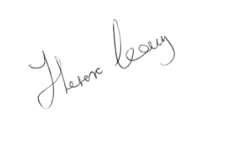
Yours faithfully

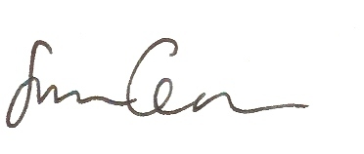
Theresa Leavy

Director of People – Children
Dorset Council
Sam Crowe

Director of Public Health for
Dorset Council and
Bournemouth, Christchurch & Poole Council

