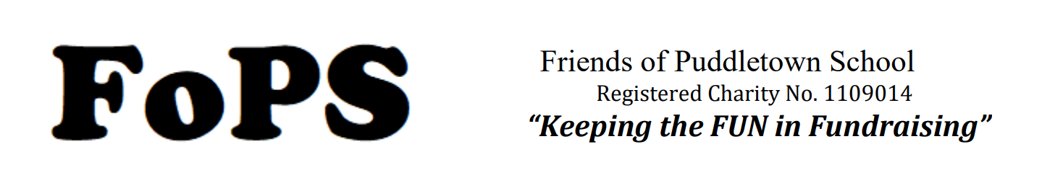

Monday 4th November 2024
Venue: The Blue Vinny 7:30-8:30pm

Attendees:

Jenny Heaver
Faith Kirby
Gemma Dayment
Tara Hill
Lisa Ashdown
Amy Waldron
Hayley Edwards
Kelly Kimberley

- Review and approval of minutes of last meeting – approved

- Future Events – CATV Thursday 5th December at 4:45pm

- Father Christmas – Lisa Ashdown to sort – sorted
- Need to purchase Hot Chocolate/ Mulled Wine/ Hotdogs/
- Hotdog food order to be in by 25th November
- Check cost of sausages (charged £2.50 in previous years) – Jenny to email Sharon about costings.
- Tombola – Bottle and toiletry donations
- Christmas Jumper stall - £1 donations. Ask for jumper donations in beforehand. Jumper reminder to go out with Tombola letter
- Gemma Dayment has made limited edition earrings - £2 for small earrings £3 for large earring. 60% of funds to be kindly donated to FOPS 40% to go to GD to recover costs
- Faith Kirby to look for volunteers to help with CATV
- Lisa Ashdown to sort a tractor/ truck
- Hayley Edwards to design a poster for requesting bottles/ gifts for tombola
- Jenny Heaver to do a cupboard check for napkins/ ketchup etc
- Faith Kirby to apply for drinks licence for CATV and Nativity
- Faith Kirby to source Mulled Wine
- Request for Slow cookers for Mulled Wine and Hot Chocolate – Lisa/ Kelly/ Gemma/ Jenny
- Need to purchase marshmallows and whipped cream.
- Glow Wands – Tara to sort and sell
- Find the buckets for collecting donations
- Type up the Risk Assessment – Jenny to consult with Mrs Seal.
- Check with Mrs Crankshaw if she is happy to lead, and which songs she would like to sing.
- CATV flyers to be printed and advertised by Friday 15th November x10 copies to distribute in the community – Done
- Faith Kirby and Amy Waldron to look at Christmas Tree Donations

- AOB
- Jenny to do a form for the Tea towels – Sorted.
- Gemma to check which Books to purchase as gifts from Father Christmas with Mrs Murphy (Literacy Lead) and Lisa Ashdown to share which books her school have purchased,

