Maths To read, write, order and recognise numbers to 20. To know number bonds for 10. To order days of the week. To recognise, name and sort 2d and 3d shapes. To be able to add and subtract a 1 digit number to and from a teen number. To be able to solve a range of simple mathematical problems.

**Music** Sing Up – Football Compose word patterns in groups. Improvise four note call-and-response vocal phrases using ‘so’ and mi-re-do. Chant together rhythmically, marking rests accurately. Play a simple ostinato on untuned percussion. Recognise the difference between a pattern with notes (pitched) and without (unpitched).

**English** To listen to and respond to; fiction texts focused around Katie Morag and the Isle of Struay. Use non- fiction books to research coastal birds found in the UK. Write a short narrative, linking simple sentences. Write instructions about making “porridgies”.

Why is there no

place like home?

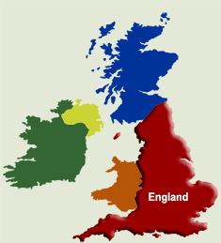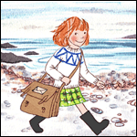

**Geography** Where is home? To use simple fieldwork and observational skills to study the geography of the school and its grounds. To use aerial photographs and plans to recognise landmarks and features. Use world maps, atlases and globes to identify United Kingdom and it’s countries as well as other countries which reflect our cultural diversity. What can maps tell us? Devise a simple map and use and construct basic symbols in a key. Know the four directions on a compass. How are places the same and different? Name and locate and identify characteristics of the four countries and capital cities of the United Kingdom.

**Science How do animals adapt to live in different places?** To be able to identify coastal birds and how they are different to garden birds (focussed on last term).

**Handwriting**

Practise lower and upper case letter formation using letter families and introduce lead out flick.

Practise numeral formation.

**Phonics** .

**Art** Explore pattern and shape by looking at geometry of windows and tartan.  **Design and Technology** Plan, make and evaluate baking “porridgies” (Scottish recipe).