Puddletown CE VC First School
Behaviour Policy

We see all learners and potential learners, and their parents and carers, as of equal value:
- whether or not they are disabled,
- whatever their ethnicity, culture, religious affiliation, national origin or national status,
- whatever their gender or gender identity,
- whatever their sexual identity.

Puddletown First School Behaviour Ethos Statement
At Puddletown First School we believe that behaviour management for our pupils should be built around support for children not control of children.
We recognise that a positive climate of engagement and self control based on positive behaviours leads to good learning.
We recognise that established routines and consistent adult behaviours are essential in providing the structure for children to flourish.
We believe that for children to engage in prosocial behaviours they must have secure self esteem. Children should be guided and taught to manage their behaviour not through fear of sanctions or the hope of reward but because they understand that that pro social behaviours lead to good outcome emotionally, academically and socially.
.
We aim to teach the children to ensure that their behaviour is;
- Helpful and intended to promote acceptance
- Aware of other and shows concern for others and their responsibility towards others
- A benefit to others and their community and that this contributes to a just community

Behaviours that are anti social affect not only those around the child but the child themselves. These behaviours may be an involuntary response to a situation rather than an active choice. Whilst this behaviour may attract a consequence all children need to be guided in repairing the situation in line with our core value of forgiveness.

We recognise that some children who find managing their feelings and behaviours a challenge will express this through externalised behaviours eg through loud and public behaviour outbursts and others through internalised behaviours eg withdrawal and ‘shut down.’

We also recognise that just like any other area of school life some children find managing their emotions and resulting behaviours challenging. This means that as in other curriculum areas these children may require additional support and learning opportunities and that this will be different for different children. This is based on the principle that equity means treating children based on their individual needs rather than equally.
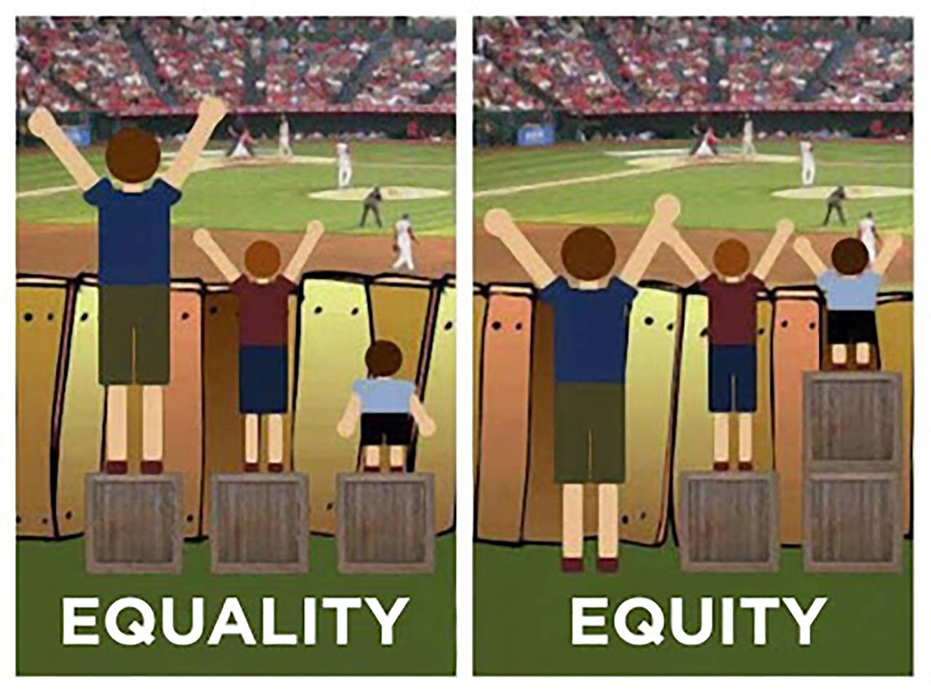

Aims of the Policy
- To encourage a calm, purposeful and happy atmosphere within the school, based on Christian principles.
- To encourage increasing self-awareness and self-discipline so that each child understands that they can be responsible for their own behaviour.
- To encourage children to understand that everyone has rights and with these come responsibilities.
- To teach the children that behaviour can be pro social or anti social and that this has consequences.
- To have a consistent approach to behaviour throughout the school, with parental co-operation and involvement.

Our policy is based on the school’s Core Values

We aim to deliver a learning environment which is built upon our Core Values of Responsibility, Acceptance Forgiveness and Justice. We define these as;

Responsibility
Accepting responsibilty for our actions and the effect they have on ourselves and others.
Accepting responsibility to use our talents to their full.
Learning to accept responsibility for stewardship of the world.

Acceptance
Accepting the differences of others.
Showing empathy and compassion for others.

Forgiveness
Learning to understand that forgiveness needs to be given and accepted and that this can be challenging.
Understanding that forgiveness can help to repair damage or hurt made.
Understanding that we all make mistakes and that we can learn from them.

Justice
Understanding that fairness is important for all.
Fairness and justice can mean supporting some more than others.
Understanding that we all have a role to play in creating a fair world.

Legal framework
This policy has due regard to all relevant legislation and statutory guidance including, but not limited to, the following:
- Education Act 1996
- Education Act 2002
- Equality Act 2010
- Education and Inspections Act 2006
- Health Act 2006
- Voyeurism (Offences) Act 2019
- The School Information (England) Regulations 2008
- DfE (2022) ‘Behaviour in schools: advice for headteachers and school staff’
- DfE (2022) ‘Keeping children safe in education 2022’
- DfE (2021) ‘Sexual violence and sexual harassment between children in schools and colleges’
- DfE (2018) ‘Mental health and behaviour in schools’
- DfE (2015) ‘Special educational needs and disability code of practice: 0 to 25 years’
- DfE (2013) ‘Use of reasonable force’
- DfE (2022) ‘Searching, screening and confiscation: advice for schools’

Roles and responsibilities
The governing board has overall responsibility for:
- Ensuring that this policy, as written, does not discriminate on any grounds, including, but not limited to, age, disability, gender reassignment, gender identity, marriage and civil partnership, race, religion or belief, sex and sexual orientation.
- Promoting a whole-school culture where calm, dignity and structure encompass every space and activity.
- Handling complaints regarding this policy, as outlined in the school’s Complaints Procedures Policy.
- Ensuring this policy is published on the school website.

The headteacher is responsible for:
- The monitoring and implementation of this policy and of the behaviour procedures at the school. This includes monitoring the policy’s effectiveness in addressing any SEMH-related drivers of poor behaviour..
- Establishing high expectations of pupils’ conduct and behaviour, and implementing measures to achieve this.
- Determining the school rules and any disciplinary sanctions for breaking the rules.
- The day-to-day implementation of this policy.
- Publicising this policy in writing to staff, parents and pupils at least once a year.
- Reporting to the governing board on the implementation of this policy, including its effectiveness in addressing any SEMH-related issues that could be driving disruptive behaviour.

The senior mental health lead is responsible for:
- Overseeing the whole-school approach to mental health, including how this is reflected in this policy, how staff are supported with managing pupils with SEMH-related behavioural difficulties, and how the school engages pupils and parents with regards to the behaviour of pupils with SEMH difficulties.
- Supporting behaviour management in line with the SEMH Policy.

The SENCO is responsible for:
- Collaborating with the governing board, headteacher and the mental health lead, as part of the SLT, to determine the strategic development of behaviour and SEMH policies and provisions in the school.
- Undertaking day-to-day responsibilities for the successful operation of the behaviour and SEMH policies to support pupils with SEND, in line with the school’s Special Educational Needs and Disabilities (SEND) Policy.
- Supporting teachers in the further assessment of a pupil’s strengths and areas for improvement and advising on the effective implementation of support.
.

All children have a responsibility to:
- Accept that they are responsible for the outcomes of their behaviour and only they can change this
- Treat others with respect
- Take care of property and the environment in and out of the school
- Co-operate with other children and adults
- Care for children and adults in the school

All staff have a responsibility to:
- Adhere to this policy when dealing with behaviour issues in school and where appropriate use the agreed behaviour scripts
- To deliver effective PSHE using Jigsaw and Trick Box to support the children in understanding what positive behaviour looks like and how to manage feelings and emotions positively
- Provide children with the appropriate vocabulary to enable talk about them to talk about their feelings
- Use personal behaviour plans where necessary and to follow advice from external agencies and professionals
- Ensure that where possible unsocial behaviours are addressed promptly before they escalate, this may involve a range of strategies and responses eg responding to a sensory need, adapting the learning activity, providing additional support for learning
- Treat all children fairly, and with respect
- Raise children’s self esteem and develop their full potential
- Provide a challenging, interesting and relevant curriculum
- Create a safe and pleasant environment, both physically and emotionally
- Use school and class charters
- Be a good role model
- Endeavour to form good relationships with parents so children see that key adults in their lives share a common aim
- Recognise that each child is an individual and to always offer a fresh start
- Be aware of all children’s needs
- The school will offer support to parents to manage behaviours effectively

All Parents have a responsibility to:
- Make their children aware of appropriate behaviour in all situations
- Encourage independence and self-discipline
- Show an interest in all that their child does in school
- Foster good relationships with the school
- Support the school in the implementation of this policy
- Be aware of the school expectations

Positive approaches
At Puddletown First School we will always take a positive approach and aim to:
- Recognise and praise good behaviours – where appropriate highlighting the impact
- Ensure that children experience success
- Ensure children know the expectations that exist in school
- Ensure that children feel recognised as individuals and as unique people that have things to offer as well as to learn.

Encouraging Good Behaviour
We will always emphasise and promote good behaviour by:
- Drawing attention to and promoting good behaviour in all children, both individually and as a class
- Respecting all children as individuals
- Modelling the desired behaviour
- Listening to children and communicating that we have heard what they say
- Having clear and agreed classroom charters
- Ensuring that children have a sense of their own success
- Maximising opportunities for children to take responsibilities for their own behaviour
- Providing individual support for children needing this through specifically designed programmes including outreach support

Strategies for Positive Encouragement
- Stickers and stars on work and on sweatshirts of individual children
- A range of rewards including ‘Shining Lights’ – linked to the core values, house points, post cards home, head teacher visits and class rewards

If a child engages in anti-social behaviours:
- Using agreed language we will ask him or her to stop misbehaving and remind them of acceptable behaviour, this includes a warning of the consequences
- If appropriate, move him or her away from the scene of the incident
- Provide structures and supported ‘stop’ time as agreed within a child’s education plan
- Where appropriate discuss the incident with the child using the agreed restorative agenda
- Remind the children of their responsibility for their behaviour
- Where appropriate a sanction may be applied. Typically this may be some loss of breaktime, ‘Golden Time’. It should not include the reduction of curriculum opportunity unless this has been agreed with the HT
- Apply reasonable restraint if necessary and it is the best interest of the child’s safety and well being

Repeated or persistent misbehaviour
Where there is repeated or persistent misbehaviour, the following process may apply:
- Withdrawal of privileges, eg playtime
- Involvement of the headteacher
- Formal contact with parents by the headteacher
- Formal recording of behaviour and related incidents
- Involvement of outside agencies
- Exclusion, temporary or permanent

Links to other Policies
This policy has clear links with these policies:
- the Anti-Bullying Policy
- School Exclusion Policy
- SEN Policy
- Child Protection and SafeguardingPolicy

Availability of this Policy.
All parents will be informed of this Policy.
It will be placed on the school website.
Other parents may request this Policy and requests should be made to the Headteacher.

Appendix 1

Reasonable restraint

Objectives
- To maintain the safety of pupils and staff
- prevent serious damage to property

Physical restraint of pupils may be necessary if a child’s behaviour puts themselves or others in danger, or they are causing significant damage to the environment.

It will be used with reference to National guidelines

Restraint will not be used to punish or force compliance. All incidents of restraint will be recorded in the ‘bound book.’

Parents will be informed on the day of the incident.

The use of force to restrain should only be used when other strategies have failed to de escalate the situation or to respond to an immediate reaction where the risk of not using force outweigh the risk of using restraint.

The use of force should be part of a behaviour management plan but it should be recognised that individual children may engage in hither to unexpected behaviours.

Force should be used on the principle of the minimum intervention needed to achieve the desired outcome.

Clear oral warnings should be given to the child before force is used.
The dignity of the pupil should be maintained.

No form of restraint that is intended to cause pain or injury should be used.

Where possible another member of staff should be present, where this is not possible help should be sought as soon as possible.

Post incident support for the child and adult should be sought. In the short term this should focus on the rebuilding of relationships. In the medium to long term a full debrief should be undertaken to review the incident, the build up and the aftermath. The areas for development should be identified and practice refined. Where a child hasn’t been part of a behaviour plan it should be reviewed to see if this is appropriate.

Appendix 2

Definitions
For the purposes of this policy, the school defines “serious unacceptable behaviour” as any behaviour which may cause harm to oneself or others, damage the reputation of the school within the wider community, and/or any illegal behaviour. This includes, but is not limited to, the following:
- Discrimination – not giving equal respect to an individual on the basis of age, disability, gender identity, marriage and civil partnership, pregnancy and maternity, race, religion or belief, sex, and sexual orientation
- Harassment – behaviour towards others which is unwanted, offensive and affects the dignity of the individual or group of individuals
- Vexatious behaviour – deliberately acting in a manner so as to cause annoyance or irritation
- Bullying – a type of harassment which involves personal abuse or persistent actions which humiliate, intimidate, frighten or demean the individual being bullied
- Cyberbullying – the use of electronic communication to bully a person, typically by sending messages of an intimidating or threatening nature
- Possession of legal or illegal drugs, alcohol or tobacco
- Possession of banned items
- Truancy and running away from school
- Refusing to comply with disciplinary sanctions
- Theft
- Verbal abuse, including swearing, racist remarks and threatening language
- Fighting and aggression
- Persistent disobedience or disruptive behaviour
- Extreme behaviour, such as violence and serious vandalism
- Any behaviour that threatens safety or presents a serious danger
- Any behaviour that seriously inhibits the learning of pupils
- Any behaviour that requires the immediate attention of a staff member

For the purposes of this policy, the school defines “low-level unacceptable behaviour” as any behaviour which may disrupt the education of the perpetrator and/or other pupils, including, but not limited to, the following:
- Low-level disruption and talking in class
- Failure to complete classwork
- Rudeness
- Refusing to complete homework, incomplete homework, or arriving at school without homework
- Disruption on transport
- Use of mobile phones without permission
- Graffiti

Reviewed: Sept 2022 – whole staff

