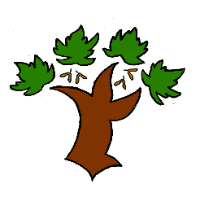
Puddletown First School
KS2 Science (Y3) – Achieving Mastery

At Puddletown First School we understand the National Curriculum to be a mastery curriculum. We believe to show mastery of the Geography curriculum children need to be able to demonstrate key skills or concepts independently. The principle behind achieving mastery in the children being able to demonstrate an ability ‘to think like a scientist’
Curriculum intent:
- To develop scientific knowledge and understanding through enquiry and observation
- To carry out a scientific enquiry answering a question about the world around them employing scientific methods and processes
- Show an understanding of how some science is used in the world they live
Working scientifically
- Ask relevant questions using different types of enquiry to solve them
- Set up simple investigations that are fair tests requiring systematic and careful observations and measurements. Presenting their findings in a variety of ways
- Use the results to draw simple conclusions and predictions as evidence when answering an enquiry or producing a report (written or oral)
Living things
- Identify and describe the functions of parts of a plant including how water is transported within a plant
- Explore the requirements of plants to thrive
- To identify the purpose of a skeleton
- To understand the role of nutrition in humans and animals
Materials
- To compare and sort rocks according to appearance and some properties
- Describe how fossils are formed
- Know that soil is composed of rocks and organic material
Light
- Understand that dark is the absence of light and can cause injury
- Know that light can be reflected
- Understand that light can be blocked to form a shadow
Forces
- To know that magnets can attract and repel each other and attract some materials
- To know that magnets have poles and predict whether they will attract each other
Key vocabulary

