FOREST SCHOOL AFTER SCHOOL CLUB
Join us from 3.15-4.15pm on Thursdays to enjoy making, learning and exploring outdoors!
Forest School Club is run by Suzy Howitz, an experienced primary school teacher with a L3 Forest School qualification. It will run for all years over the next Half Term at a cost of £30 for the 6 sessions (see below for payment information)
* PLEASE NOTE *once your child’s place has been accepted by school, payment must be made PROMPTLY by THURS 28th March or the space will be readvertised:
Thursdays: 18th, 25thApril, 2nd, 9th, 16th, 23th May
Limited to only 12 places!
Please note children may well get dirty; send old clothes and boots.
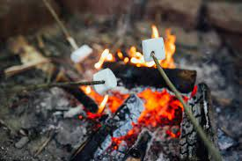

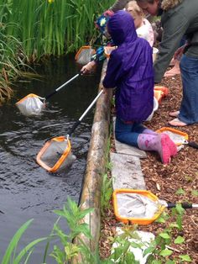

Fires… whittling…

pond dipping…
den building and much more!!
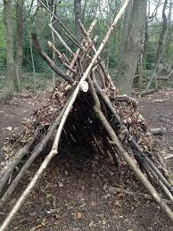
Children may well be using tools, safely and under close supervision. However, activities could result in children being injured; although the utmost care will be taken, no liability can be accepted.
Please pay direct to: Mrs Suzanne Curtis Howitz
Sort code: 202662
Account number: 33488942

