PUDDLETOWN VC CE FIRST SCHOOL NEWSLETTER

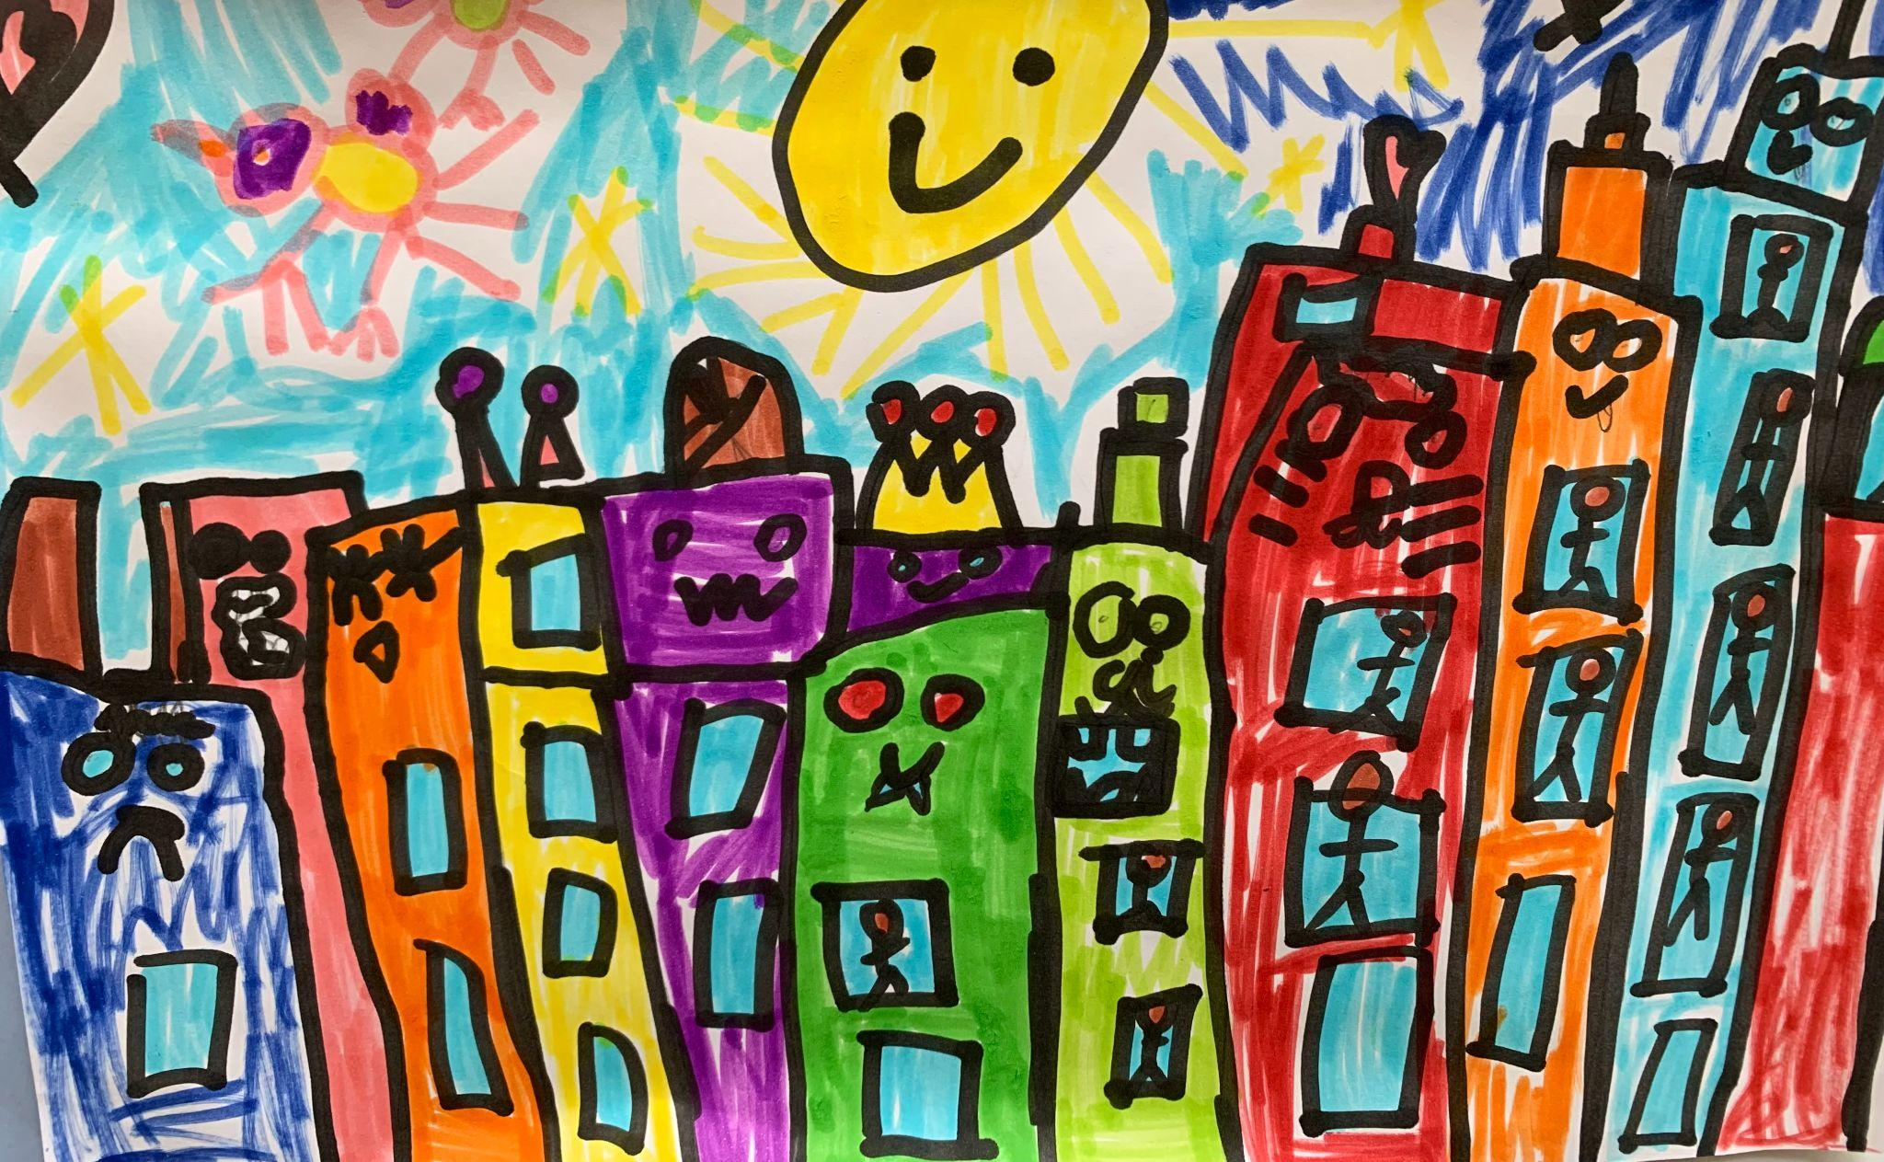 | 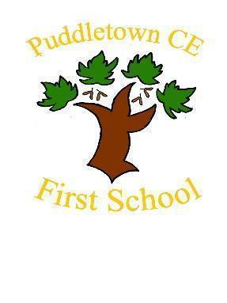
 | June 2024
 | 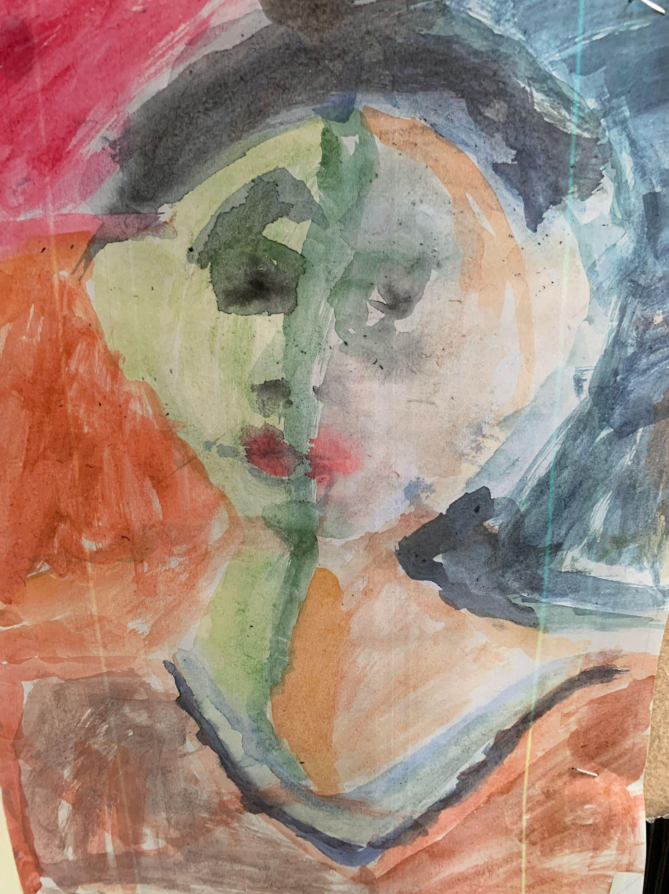
June 2024 News | Reminders
Thank you to all the families that filled in our recent survey. It is really important to me that we gather your views and work together to make this the best school it can be. It was heartening to see that the overwhelming majority of you, that responded, feel happy with the school and that your child feels safe and is learning well.  Three main areas came up that could be improved upon. Communication around the curriculum your child is being taught and understanding what are the national expectations we work to, More work around supporting our dysregulated pupils better and communication in general.  It was interesting to see that the areas you highlighted were also ones that we have been working on in our school development plan this year. There are always lots of things going on behind the scenes in schools that can sometimes take a while to come to fruition. We have been working on revamping our foundation subjects curriculum to ensure that all our children can develop their skills and knowledge in a progressive way over their time here. We are really excited that this curriculum provides lots of exciting, diverse and ambitious experiences for your children. It has been fantastic to see the Art skills and knowledge coming through with these new projects. I have included some photos of year 1‘s work based on the artist James Rizzi and I know that the children have loved it, going home to make even more pictures in the style of this artist! In year 4 they have been looking at warm and cool colour palettes, complimentary colours and improving their mixing skills. There have also been some fantastic DT projects with children working together to problem solve with materials. There has been a real buzz and engagement with these projects. The History curriculum has led to year 2 pupils explaining absolute monarchy to me! At Puddletown we really, passionately believe that a broad and balanced curriculum provides our children with experiences to develop all their skills and interests and can inspire lifelong passions.  The whole Wessex mat is in process of upgrading their IT systems and this will involve big works here in school and also a new website. As you can imagine, these are big projects so please bear with us while we change over. We are hoping to start the new year with our new website showing curriculum plans for each year group so you can see what your child’s learning will look like over their time with us. We have also been working on updating and formalising procedures around supporting regulation, relationships and behaviours in school which we will share with you when completed. With the new IT systems in place we are hoping they will provide us with more ways of communicating with you to enable you to be better informed. As always, the staff and myself endeavour to be available to you to discuss your child’s learning, well being and address any concerns you have.  Fops have also been working hard behind the scenes and we have some fantastic new wooden benches and shade umbrellas to enable children to work and rest outside in the shade. They have also kindly bought some sun shade sails which we will put up on the field as soon as they arrive. A big thank you to our professionally skilled parent that made them and installed them. We are all looking forward to the big FOPS end of year social on 12th July as a lovely way to end the school year, meet other parents and build and strengthen our school community which is at the heart of supporting all our children. See the link to get your tickets  https://forms.office.com/r/mR6ihkuFi0  Only a few more weeks to go but lots of fun and learning still to be packed in.  Mrs Anna Seal Head of school | 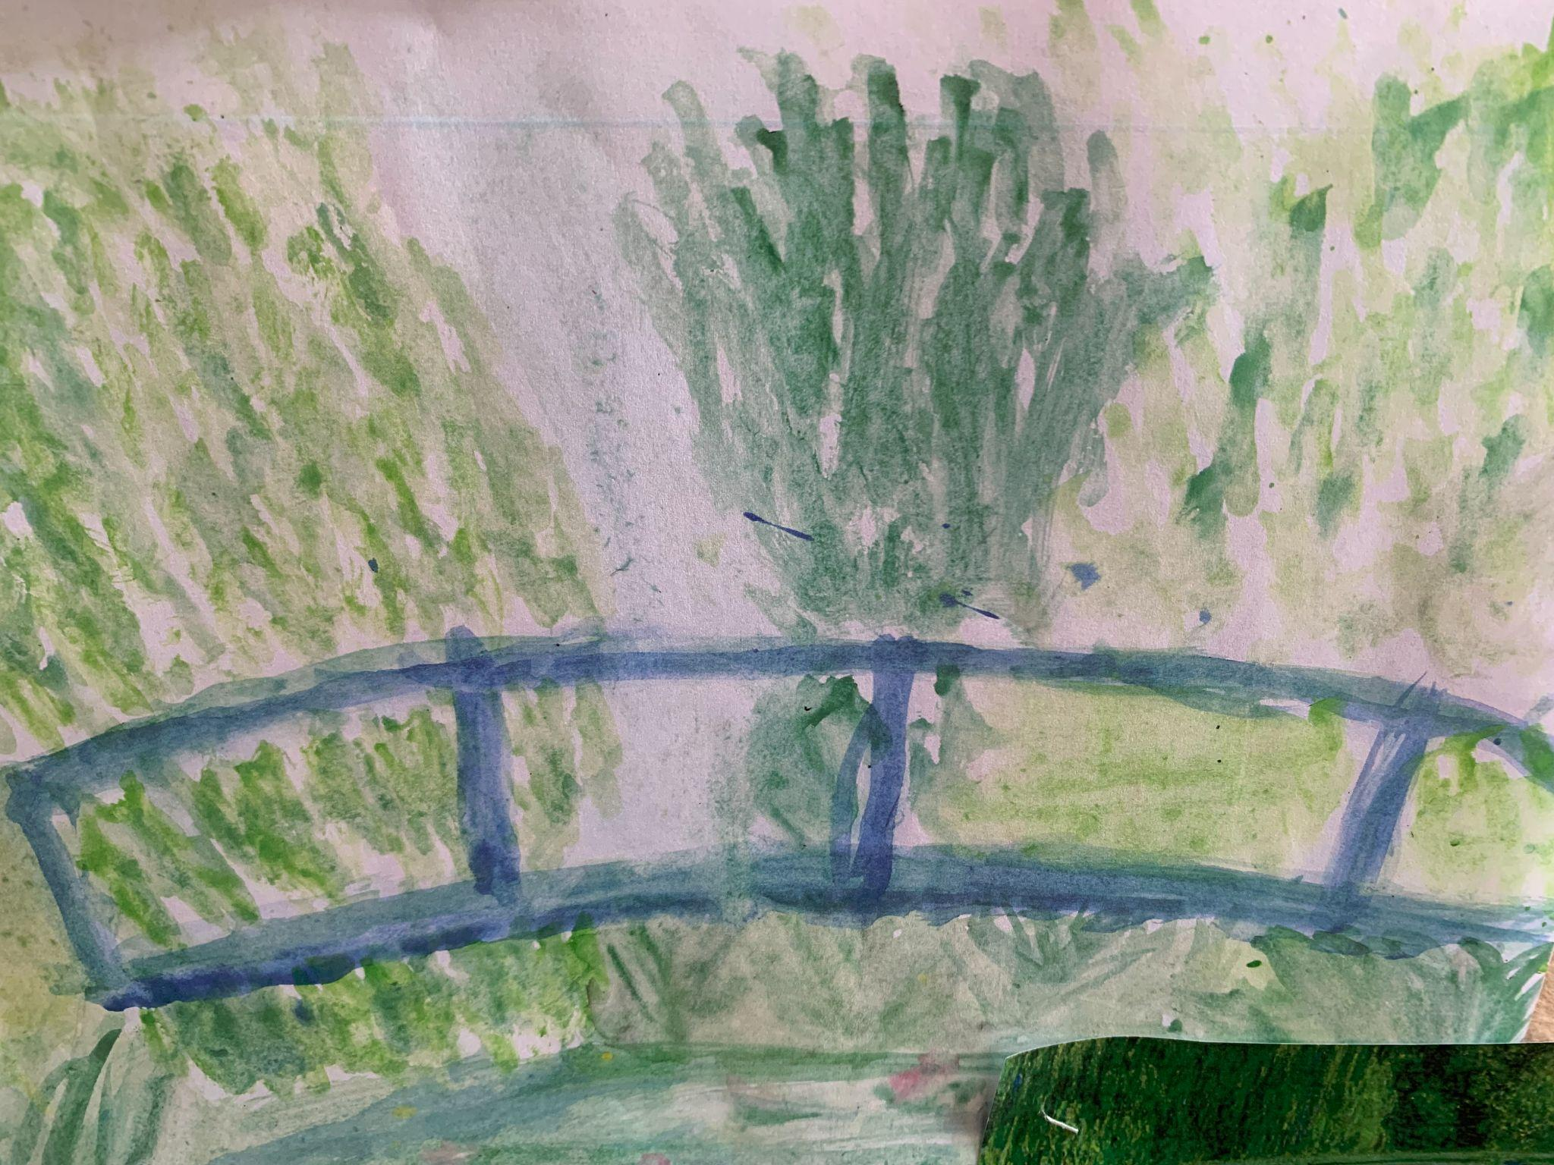  SUN SAFETY  Please put sun protection on at home and send your child in with a hat and a water bottle.  Reports  These will be sent home with your children on Friday 5th July.  Year 4 transfer day  reminder that parents need to drop off and pick up from St Marys on that day.    Meet the new teacher  2.30pm 7th July  Year 2 NSPCC speak out stay safe workshop 8th July  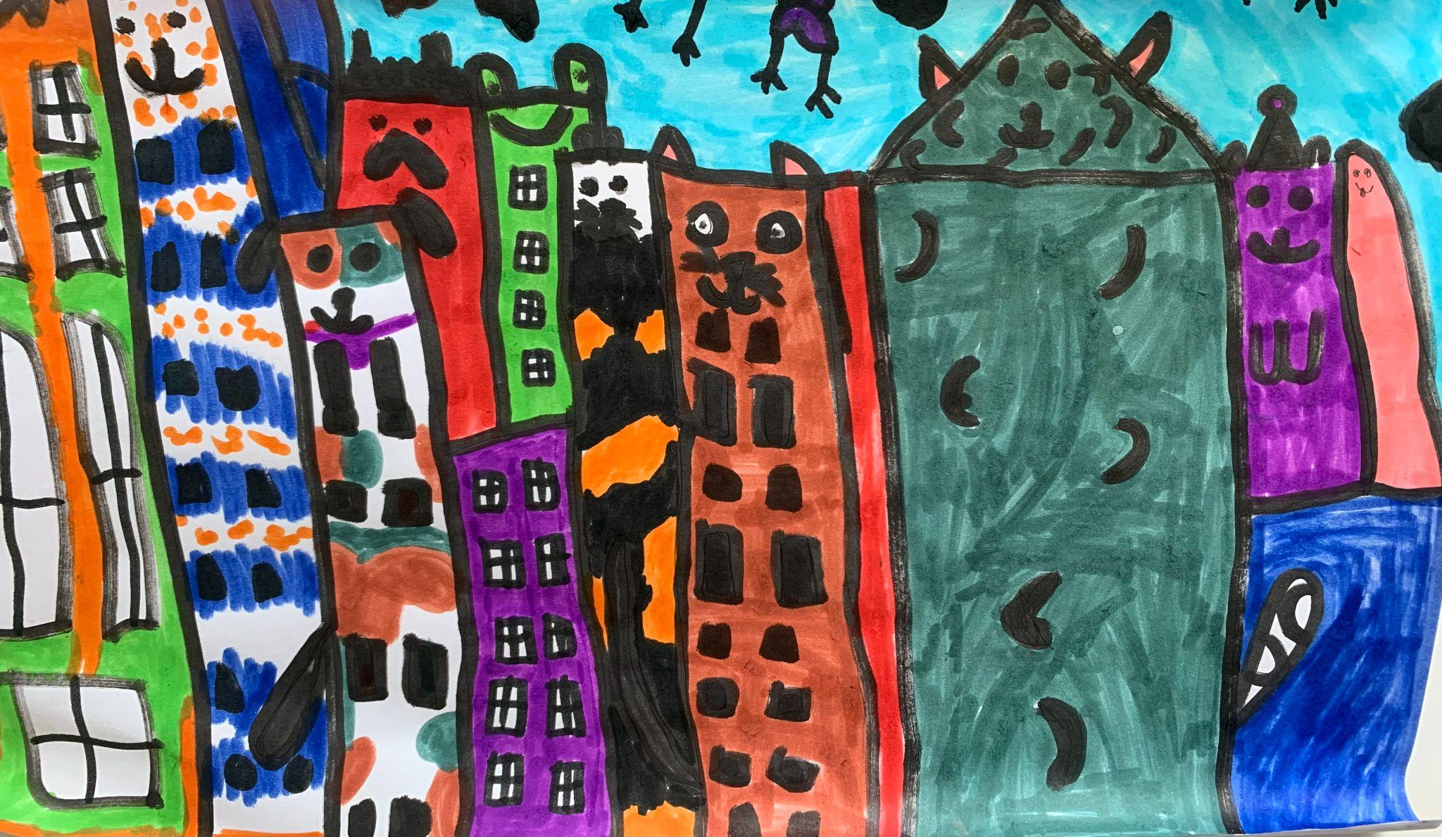  Year 3 DEED workshop on stereotyping and being an inclusion advocate. 9th July  Sports day  whole school 12th July

