PUDDLETOWN VC CE FIRST SCHOOL NEWSLETTER

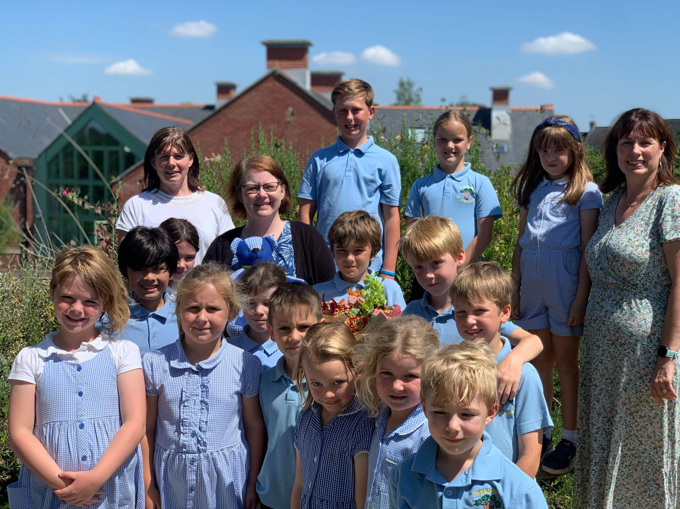 | 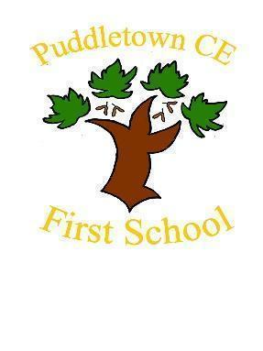
 | July 2024
 | HAVE A WONDERFUL HOLIDAY
July 2024 News | Reminders
Wow! What an amazing year!  Another incredible year has passed and it has been wonderful to see your children flourish at this school.  The end of term often brings some changes and it is with heavy hearts that we say goodbye to Miss Reeve. She has been a stalwart of Puddletown first school for 22 years and has seen the school through many times and taught many, many children. We held an emotional assembly for her where gifts from you, staff, children and governors were bestowed upon her. Year 4 sang their ‘count on me’ song which was a perfect choice for our maths lead! We wish Miss Reeve all the best on her next adventures and we are sure we will see her again in school.  The year 4s knew exactly how Miss Reeve was feeling as they have gone through their own last days here too. The leavers assembly was full of stories of the children’s time here and some strong memories and lasting friendships have been made. The children wrote about their ideal jobs and lives when they grew up and it was inspiring to hear how many kind, caring and ambitious future adults we will have had a part in creating.  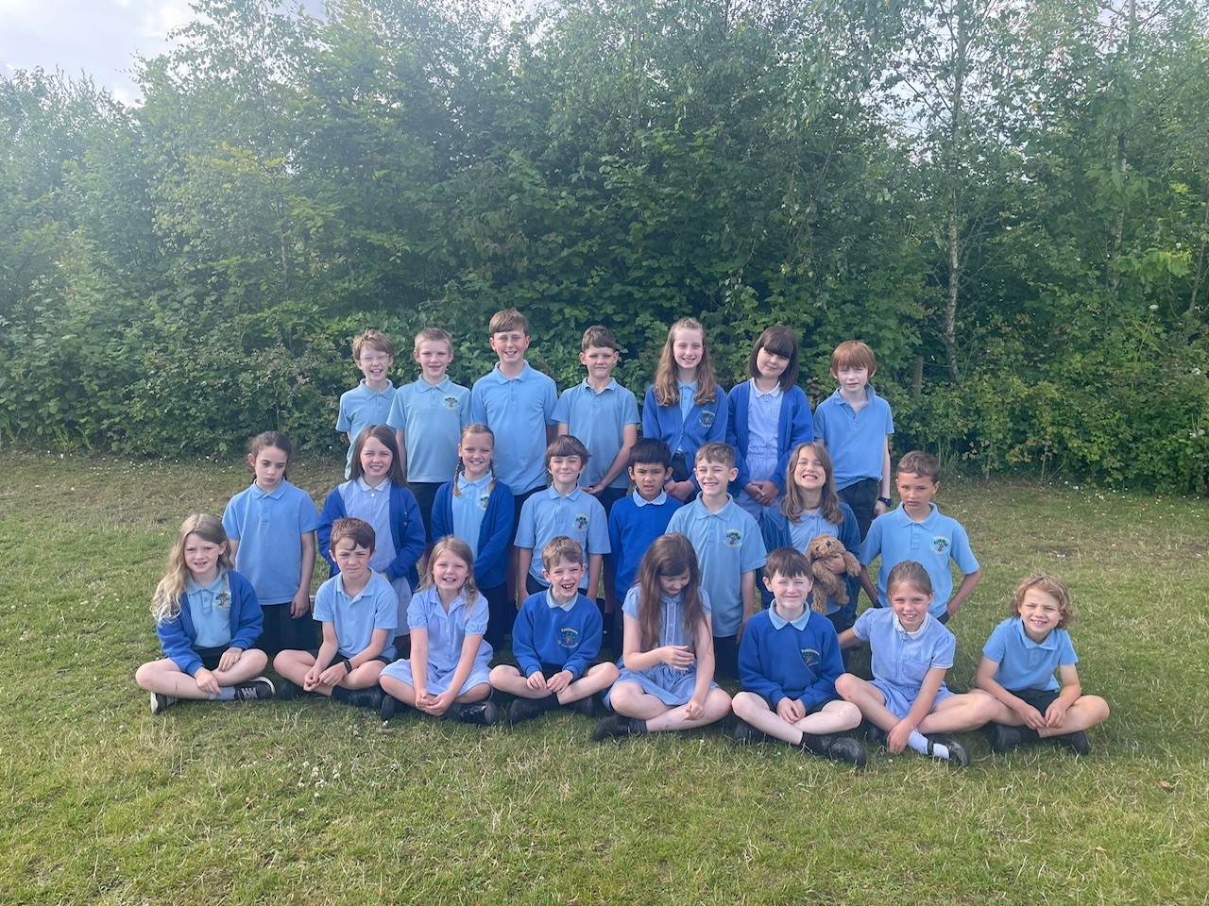  We also awarded our Class awards to pupils that have demonstrated our school values consistently over the year. They were voted for by their classmates and it is so interesting to witness how accurately the children notice those in their classes that really live those values out. Well done to all who received one.  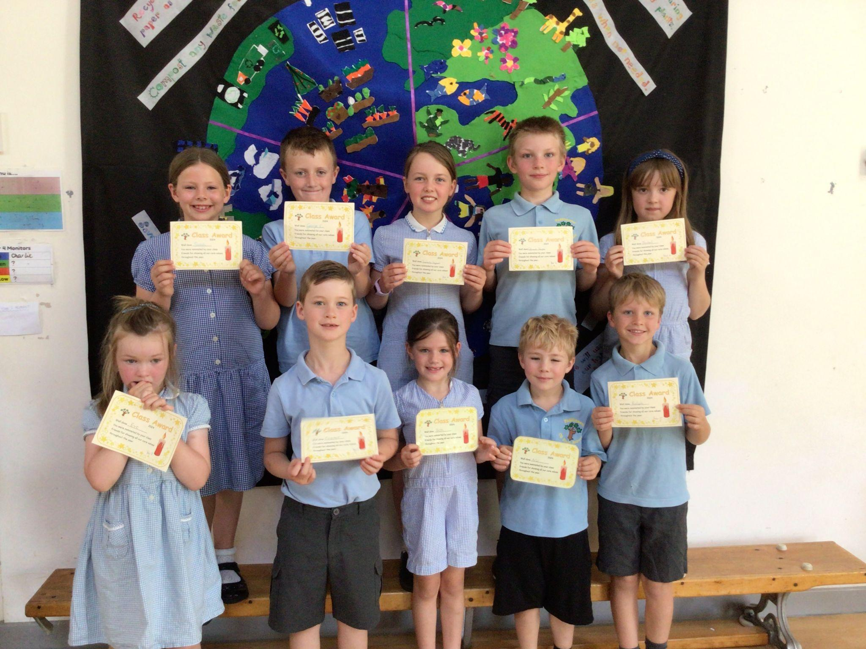  It is also the end of my first year as your new head, and I would like to thank you all for accepting me into this wonderful school and community and supporting us to continue to make this an exceptional school experience for your children.  We are having a website and IT upgrade over the holidays so please bear with us while we make these changes. We hope to have our new website live during September  The staff and Governors would like to thank you for all your gifts and kind words and we wish you all a wonderful Summer holiday.  Mrs Anna Seal Head of school | Children return Tuesday 3rd September.  Back packs and bags.  Please can children just bring a book bag to school and carry their lunch box, drinks bottle. We do not have room in school for backpacks and bags. Book bags are easier for staff and children to locate and swap books, homework etc  Uniform  Uniform policy is on the website for your reference.

