**Maths**

Count, read, write, order and compare numbers to 10 and beyond. Make number bonds and stories with numbers to 10 involving one more and one less. Solve problems involving addition and make number stories.

**Geography** Where do I live? How is my home different to others homes? Focus on Puddletown; look at features and the river. Look at maps and photographs of the village. Find out where in the world Puddletown is.

**English**

To listen to and respond to; non –fiction texts about the human body, senses and garden birds. Fiction texts; Dogger, Mog and the V.E.T, and a selection of poetry.

Orally compose and ask questions.

Learn and recite poem

Write labels and sentences.

What Makes Me Unique?

**Handwriting**

Practise lower case letter formation using letter families.

Practise numeral formation.

**Art** What are my features?Look at ourselves and make paper sculptures of us! What are my favourite things? Create a painting using hands and feet

[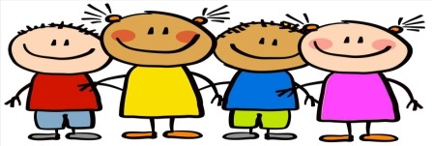](https://www.google.co.uk/url?sa=i&rct=j&q=&esrc=s&source=images&cd=&cad=rja&uact=8&ved=2ahUKEwiTkaOMi5fcAhXEvxQKHQSNDpkQjRx6BAgBEAU&url=https://trckroi.com/kids-making-craft-clipart/&psig=AOvVaw0SSqDwjIdkZD0F672ob9yy&ust=1531399694379035)

**Phonics**

**Science** Do we all have the same body parts?Identify and name basic parts of the human body.Do we all like the same smells, sounds. tastes, sights and touch sensations? Name and explore using the 5 senses and identify the part of the body associated with each sense (eg, smell – nose). Do we all like the same animals?Identify and name a variety of common animals, (pets and garden birds).

**History** How is my history different to others history? Look at our own history from a baby to year 1. Sequence events in our own life. Ask questions to find out about the past.