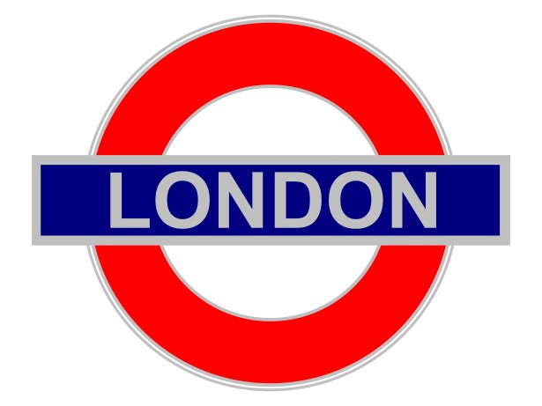
This term the year 2 topic will be……..
In Maths we are learning to…
… read, write and order numbers to 100.
… count in steps of 2,3 and 5
… recognise the place value of digits.
… use place value to solve problems.
… learn the 10 times table
… recognise and name 2D shapes
…read and draw picture graphs, tally and charts.
…tell the time to the nearest quarter of an hour

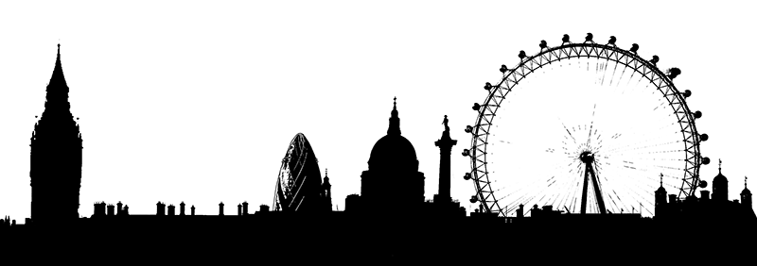 London
In English we are learning to…
… write questions and statements
… write diary entries
… find out facts and make notes
… make information texts about London
… read and write senses poems
(To include Science focus weeks)
In Art we are …
… exploring line, shape and colour and using a range of materials and techniques (including clay)

In PSHE we are thinking about …
‘Being me in my world’ and considering rules, responsibilities, rewards and consequences.
In RE we are …
… exploring parables

In music we are …
… learning to sing and play together in an ensemble

In computing we are …
… using Word to create text
… simulation games
… using mathletics
… researching information

In Geography we are …
…..identifying countries of the UK
…...recognising key features of London
…….using maps and atlases

In History we are …
………learning about a significant people and events- Great Fire of London, Gunpowder plot and Remembrance
…….Thinking about how life has changed from in the past to present day.

In our Science focus weeks we are thinking about …
……….Lifecycles of humans and other animals
…..Basic needs of animals and humans for survival
………Importance of exercise, eating a balanced diet and hygiene.
….properties of materials- identifying, comparing and changing materials

In PE we are …
… learning gymnastic sequences
… learning football skills
… creating dance sequences

