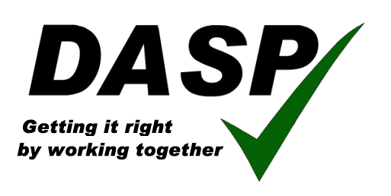
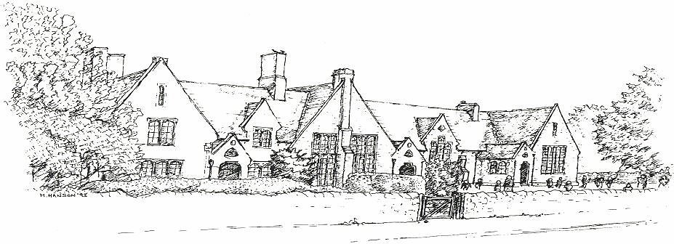
Puddletown CE VC First School Home-School Agreement

‘Inspiring learners to be the best they can be’

The school is responsible for providing: | The family is responsible for: | The children are responsible for:
- A happy and secure Christian environment where each child is valued.  - Teaching and support that will enable all children to do the very best they can.  - Teachers and staff who respect children and parents.  - A broad and balanced curriculum, which meets the individual needs of your child.  - Regular information about your child’s progress and behaviour and keep you informed about general school matters.  - A positive welcome and genuine response  to parental concerns.  - Home learning appropriate to the age of your child. | - Ensuring your child arrives at school on time (between 8.30 and 8.45am).  - Ensuring your child attends school regularly and providing a note of explanation if our child is absent.  - Supporting the school in reinforcing expectations for behaviour.  - Encouraging and supporting your child’s effort and achievement.  - Supporting home learning including reading, number bonds and times tables  - Sharing with the school any concerns or problems that may affect your child’s work or behaviour.  - Attending parent consultation evenings to discuss your child’s progress.  - Reading and responding to school communications  - Ensuring that your child attends school in their uniform and has the appropriate equipment.  - Supporting the application of the Acceptable Use Policy for for ICT | - Striving to reach the outcomes of the DASP citizen outlined in the Community Charter and to match the expectations of the School’s Core Values;  - Acceptance  - Responsibility  - Justice  - Forgiveness  - Being a good friend  - Caring for others  - Being a good listener  - Being polite and helpful  - Being honest  - Always trying their best  - Looking after property  - Completing the home learning tasks  - Using ICT and the internet safely and responsibly

By signing to our Home - School Agreement I also understand that I am consenting to my child taking part in visits to the local area eg the church, library, St Mary’s Middle School etc

Signed………………………………………………………………………………………………….. Headteacher

Signed…………………………………………………………………………………………………… Parent / Guardian

Signed…………………………………………………………………………………………………… Child

Please remember that this is an important agreement, which is at the heart of an effective relationship between home and school. The well being and progress made by children depends on its principles being fully supported.

