**English** To listen to and respond to; poetry, fiction and non-fiction texts focused around weather/ growing and flowering plants and trees. Write a set of instructions about making a kite. Write an adventure story. Practise using letter names and alphabetical order.

**Maths**  Add and subtract single digit numbers to and from 2 digit numbers. Solve one step problems involving counting in 2’s, 5’s and 10’s. Find a ½ and ¼ of shapes and numbers. Solve word problems involving number bonds and missing number problems. To measure weight, length & capacity using non standard and standard units.

**Computing** Understand what an algorithm is. Create a simple program. Use technology safely and respectfully, identifying where to go for help and support when they have concerns about content or contact on the internet or other online technologies.

What Cycles can We See In Nature?

**Handwriting** Practise lower and upper case letter formation using letter families and introduce lead out flick. Practise numeral formation.

**Sustainability** How can humans create a better life cycle? Learn how natures cycles have no waste. Devise checklist as to how we can be less wasteful as we journey through our cycle.

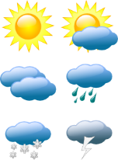[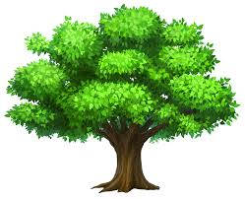](http://www.google.co.uk/url?sa=i&rct=j&q=&esrc=s&source=images&cd=&cad=rja&uact=8&ved=0CAcQjRw&url=http://galleryhip.com/clipart-oak-tree.html&ei=25oIVYnBC4j1UJ_2grgF&psig=AFQjCNFlopzF4lwYLGDLFezvez4rIn0WRw&ust=1426713663656040)

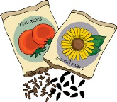[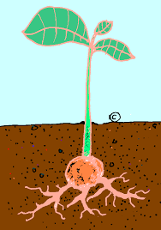](http://www.google.co.uk/url?sa=i&rct=j&q=&esrc=s&source=images&cd=&cad=rja&uact=8&ved=0CAcQjRw&url=http://www.neoclipart.com/plants-clipart/14050-wastewater-treatment-plants-clipart.html&ei=TJwIVeDxAovwUq29hOAP&psig=AFQjCNExp7J5oofJECMxi0YUFa_gGeMS9g&ust=1426714042454474)

**Design and Technology** Which is the best season to fly a kite? Explore and list features of a kite. Test which material makes a kite fly highest. Plan and make a kite that can fly. Evaluate a product they have made.

**Phonics**

**Science** Does the weather stay the same? To state the four seasons and associated weather. How do we know what the weather is like? Make a rain gauge and measure rainfall. How do plants change across the seasons? Identify and label leaves, flowers (blossom), petals, fruit, roots, bulb, seed, stem, trunk, bark, branches, fruit and blossom. Why do sunflowers have seeds? Use observations and ideas to suggest answers to questions; link to Fibonacci. What do plants need to grow? What plants and trees can we see in the environment? Identify and name deciduous and evergreen trees (eg; ash, oak, birch, beech, pine) and that they need light, water and soil to grow.